3811ICT assignment report

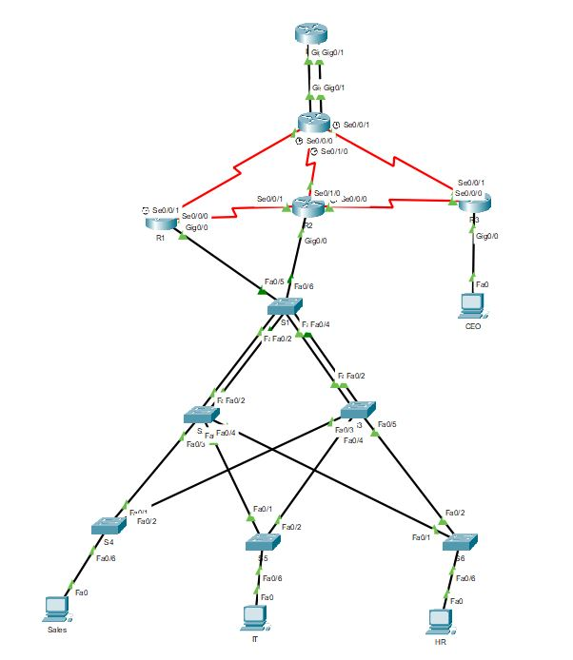

**Vlsm table ipv4**

|  |  |  |  |  |  |  |  |
| --- | --- | --- | --- | --- | --- | --- | --- |
| Name | No. host | Min size | prefix | Subnet mask | Network address | 1st host | Broadcast address |
| Vlan 10 | 100 |  | /25 | 255.255.255.128 | 132.234.82.128 | 132.234.82.129 |  |
| Vlan 20 | 200 |  | /24 | 255.255.255.0 | 132.234.81.0 | 132.234.81.1 |  |
| Vlan 30 | 50 |  | /26 | 255.255.255.192 | 132.234.83.128 | 132.234.83.129 |  |
| Vlan 40 | 5 |  | /29 | 255.255.255.248 | 132.234.83.224 | 132.234.83.225 |  |
| Lo1 |  |  |  |  |  |  |  |
| Lo2 | 230 |  | /24 | 255.255.255.0 | 132.234.80.0 | 132.234.80.1 |  |
| Lo3 | 120 |  | /25 | 255.255.255.128 | 132.234.82.0 | 132.234.82.1 |  |
| Lo4 | 80 |  | /25 | 255.255.255.128 | 132.234.83.0 | 132.234.83.1 |  |
| Vlan 99 |  |  |  |  |  |  |  |
| Gateway- R1 | 4 |  | /30 | 255.255.255.252 | 132.234.83.232 | 132.234.83.233 |  |
| Gateway- R2 | 4 |  | /30 | 255.255.255.252 | 132.234.83.236 | 132.234.83.237 |  |
| Gateway- R3 | 4 |  | /30 | 255.255.255.252 | 132.234.83.240 | 132.234.83.241 |  |
| R1-R2 | 4 |  | /30 | 255.255.255.252 | 132.234.83.244 | 132.234.83.245 |  |
| R2-R3 | 4 |  | /30 | 255.255.255.252 | 132.234.83.248 | 132.234.83.249 |  |

**Vlsm table ipv6**

|  |  |  |  |  |
| --- | --- | --- | --- | --- |
| Name | Network | prefix | 1st host | Broadcast/ last host |
| Vlan 10 | 2001:DB8:ACAD:10::1 | /64 |  |  |
| Vlan 20 | 2001:DB8:ACAD:20::1 | /64 |  |  |
| Vlan 30 | 2001:DB8:ACAD:30::1 | /64 |  |  |
| Vlan 40 | 2001:DB8:ACAD:40::1 | /64 |  |  |
| Lo1 | 2001:50:50:50::50 | /64 |  |  |
| Lo2 | 2001:DB8:ACAD:50::1 | /64 |  |  |
| Lo3 | 2001:DB8:ACAD:60::1 | /64 |  |  |
| Lo4 | 2001:DB8:ACAD:70::1 | /64 |  |  |
| Vlan 99 | 2001:DB8:ACAD:99::1 | /64 |  |  |
| Gateway- R1 | 2001:DB8:ACAD:1000::1 | /64 |  |  |
| Gateway- R2 | 2001:DB8:ACAD:2000::1 | /64 |  |  |
| Gateway- R3 | 2001:DB8:ACAD:3000::1 | /64 |  |  |
| R1-R2 | 2001:DB8:ACAD:4000::1 | /64 |  |  |
| R2-R3 | 2001:DB8:ACAD:5000::1 | /64 |  |  |
|  |  |  |  |  |
|  |  |  |  |  |
|  |  |  |  |  |

|  |  |  |
| --- | --- | --- |
| Device | IP Address | Ipv6 address |
| Sales (pc) | DHCP | slaac |
| IT (pc) | DHCP | Slaac |
| HR (pc) | DHCP | Slaac |
| CEO (pc) | 132.234.83.226 | 2001:DB8:ACAD:40::2 |
| Lo2 | 132.234.80.2 /24 | 2001:DB8:ACAD:50::1/64 |
| Lo3 | 132.234.82.2 /25 | 2001:DB8:ACAD:60::1/64 |
| Lo4 | 132.234.83.2 /25 | 2001:DB8:ACAD:70::1/64 |
|  |  |  |
|  |  |  |

**Port configuration**

R1

|  |  |  |  |
| --- | --- | --- | --- |
| Port | Ipv4 | mask | Ipv6 |
| S0/0/0 | 132.234.83.233 | 255.255.255.252 | 2001:DB8:ACAD:1000::2/64 |
| S0/0/1 | 132.234.83.245 | 255.255.255.252 | 2001:DB8:ACAD:4000::2/64 |
| lo2 | 132.234.80.2 | 255.255.255.0 | 2001:DB8:ACAD:50::1/64 |
| Lo3 | 132.234.82.2 | 255.255.255.128 | 2001:DB8:ACAD:60::1/64 |
| g0/0.10 | 132.234.82.131 | 255.255.255.128 | 2001:DB8:ACAD:10::2/64 |
| G0/0.20 | 132.234.81.3 | 255.255.255.0 | 2001:DB8:ACAD:20::2/64 |
| G0/0.30 | 132.234.83.131 | 255.255.255.192 | 2001:DB8:ACAD:30::2/64 |
|  |  |  |  |

R2

|  |  |  |  |
| --- | --- | --- | --- |
| Port | Ipv4 | mask | Ipv6 |
| g0/0.10 | 132.234.82.130 | 255.255.255.128 | 2001:DB8:ACAD:10::3/64 |
| G0/0.20 | 132.234.81.2 | 255.255.255.0 | 2001:DB8:ACAD:20::3/64 |
| G0/0.30 | 132.234.83.130 | 255.255.255.192 | 2001:DB8:ACAD:30::3/64 |
| S0/0/0 | 132.234.83.250 | 255.255.255.252 | 2001:DB8:ACAD:5000::3/64 |
| S0/0/1 | 132.234.83.246 | 255.255.255.252 | 2001:DB8:ACAD:4000::3/64 |
| S0/1/0 | 132.234.83.237 | 255.255.255.252 | 2001:DB8:ACAD:2000::3/64 |
|  |  |  |  |
|  |  |  |  |

R3

|  |  |  |  |
| --- | --- | --- | --- |
| Port | Ipv4 | mask | Ipv6 |
| S0/0/0 | 132.234.83.249 | 255.255.255.252 | 2001:DB8:ACAD:5000::4/64 |
| S0/0/1 | 132.234.83.242 | 255.255.255.252 | 2001:DB8:ACAD:3000::4/64 |
| G0/0.40 | 132.234.83.225 | 255.255.255.248 | 2001:DB8:ACAD:40::1/64 |
| lo4 | 132.234.83.2 | 255.255.255.128 | 2001:DB8:ACAD:70::1/64 |

Gateway

|  |  |  |  |
| --- | --- | --- | --- |
| Port | Ipv4 | mask | Ipv6 |
| G0/1 | 200.100.100.6 | 255.255.255.252 | 2001:DB8:ACAE::2/64 |
| G0/0 | 200.100.100.2 | 255.255.255.252 | 2001:DB8:CAFE::2/64 |
| s0/0/0 | 132.234.83.234 | 255.255.255.252 | 2001:DB8:ACAD:1000::5/64 |
| s0/0/1 | 132.234.83.241 | 255.255.255.252 | 001:DB8:ACAD:3000::5/64 |
| s0/1/0 | 132.234.83.238 | 255.255.255.252 | 2001:DB8:ACAD:2000::5/64 |
|  |  |  |  |
|  |  |  |  |

ISP

|  |  |  |  |
| --- | --- | --- | --- |
| Port | Ipv4 | mask | Ipv6 |
| Lo1 | 50.50.50.50 | 255.255.255.0 | 2001:50:50:50::50/64 |
| G0/1 | 200.100.100.5 | 255.255.255.252 | 2001:DB8:ACAE::1/64 |
| G0/0 | 200.100.100.1 | 255.255.255.252 | 2001:DB8:CAFE::1/64 |
|  |  |  |  |
|  |  |  |  |

**DHCP Design**

The dhcp pool was placed on router 2 (r2). This was because router 2 was at the center of the network. The dhcp pool has to be placed on either router one or two as these two routers are the only ones that the switches are connected to and are the first routers that the pc can discover. In using these two routers we can getaway without using any dhcp relays. The end devices of vlan 10, 20 and 30 were able to obtain ips through the dhcp pool.

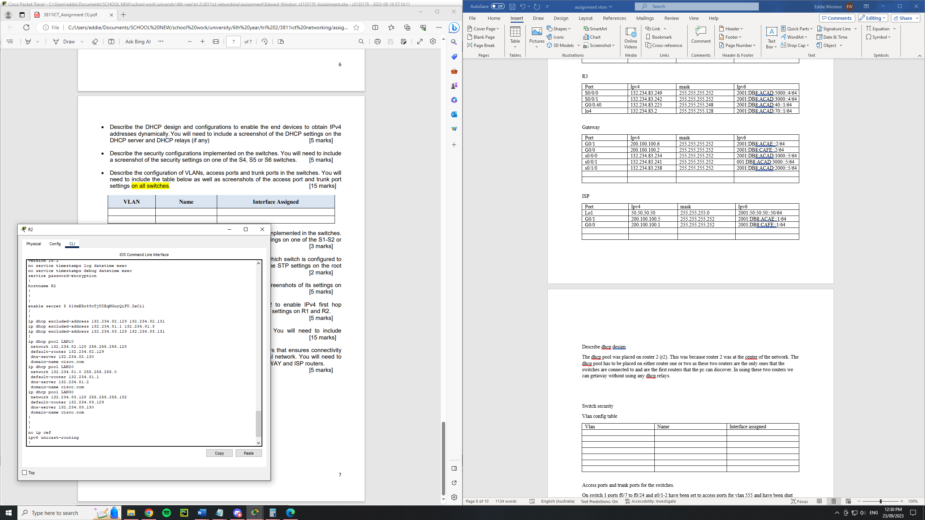

**Switch security**

In the switches the commands no negotiate was used on all the trunk ports to disable dtp negotiations. This is to prevent attacks via dtp. On the access ports they were configured with only their vlan. Ie for s4 f0/6 it was switchport access vlan 10. On the same access port it was configured with port security maximum 3, mac-address sticky and violation shutdown. This combination of commands makes it so that port can oly have a maximum of 3 different mac address and if there is more then the port will shut down. This is to prevent mac address table attacks. This can all be seen below.

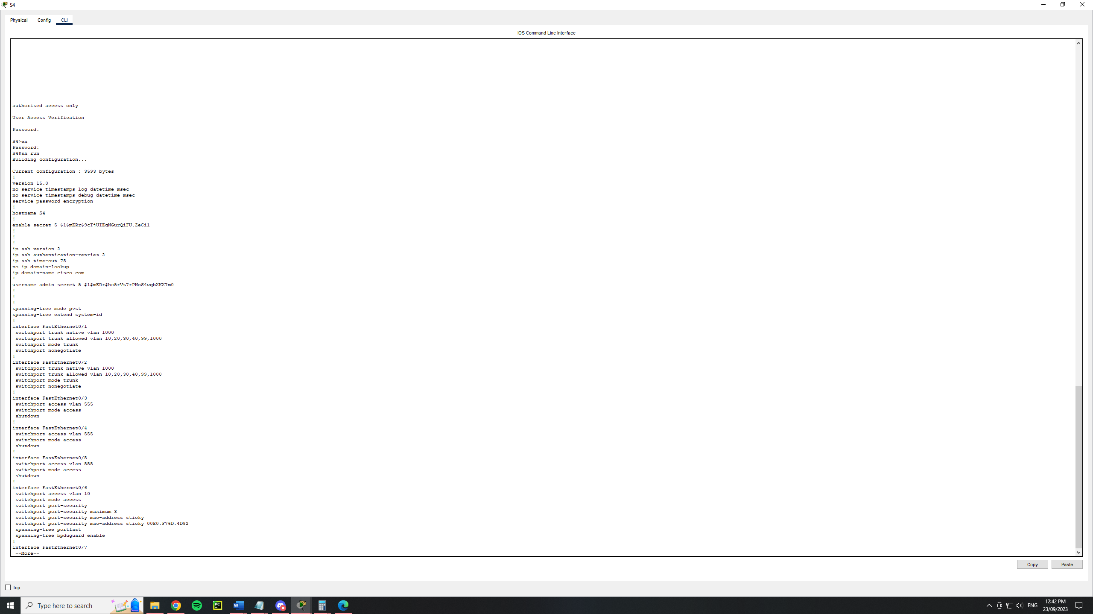

**Vlan config table**

|  |  |  |
| --- | --- | --- |
| Vlan | Name | Interface assigned |
| 10 | Sales | S4 fa0/6 |
| 20 | IT | S5 fa0/6 |
| 30 | HR | S6 fa0/6 |
| 40 | CEO | R3 g0/0 |
| 99 | Management | S1, s2, s3, s4, s5, s6 |
| 1000 | Native |  |
| 555 | Parking_Lot | All unassigned switch ports |

Access ports and trunk ports for the switches.

On switch 1 ports f0/7 to f0/24 and g0/1-2 have been set to access ports for vlan 555 and have been shut down. Ports f0/1 and f0/2 have been assigned to port channel 1 and were made to be trunk ports with vlans 10,20,30,40,99,1000 being allowed. Ports f0/3 to f0/4 we assigned to port channel 2 and were made to be trunk ports which allowed vlans 10,20,30,40,99,1000.

On switch 2 ports f0/6 to f0/24 and g0/1-2 have been set to access ports for vlan 555 and have been shut down. Ports f0/1 and f0/2 have been assigned to port channel 1 and were made to be trunk ports with vlans 10,20,30,40,99,1000 being allowed. Ports f0/3, f0/4 and f0/5 were made to be trunk ports which allowed vlans 10,20,30,40,99,1000.

On switch 3 ports f0/6 to f0/24 and g0/1-2 have been set to access ports for vlan 555 and have been shut down. Ports f0/1 and f0/2 have been assigned to port channel 1 and were made to be trunk ports with vlans 10,20,30,40,99,1000 being allowed. Ports f0/3, f0/4 and f0/5 were made to be trunk ports which allowed vlans 10,20,30,40,99,1000.

On switch 4 ports f0/3 to f0/5, f0/7- f0/24 and g0/1-2 have been set to access ports for vlan 555 and have been shut down. Ports f0/1 and f0/2 were made to be trunk ports which allowed vlans 10,20,30,40,99,1000. Port f0/6 was made to be an access port which allowed vlan 10.

On switch 5 ports f0/3 to f0/5, f0/7- f0/24 and g0/1-2 have been set to access ports for vlan 555 and have been shut down. Ports f0/1 and f0/2 were made to be trunk ports which allowed vlans 10,20,30,40,99,1000. Port f0/6 was made to be an access port which allowed vlan 20.

On switch 6 ports f0/3 to f0/5, f0/7- f0/24 and g0/1-2 have been set to access ports for vlan 555 and have been shut down. Ports f0/1 and f0/2 were made to be trunk ports which allowed vlans 10,20,30,40,99,1000. Port f0/6 was made to be an access port which allowed vlan 30.

On S1

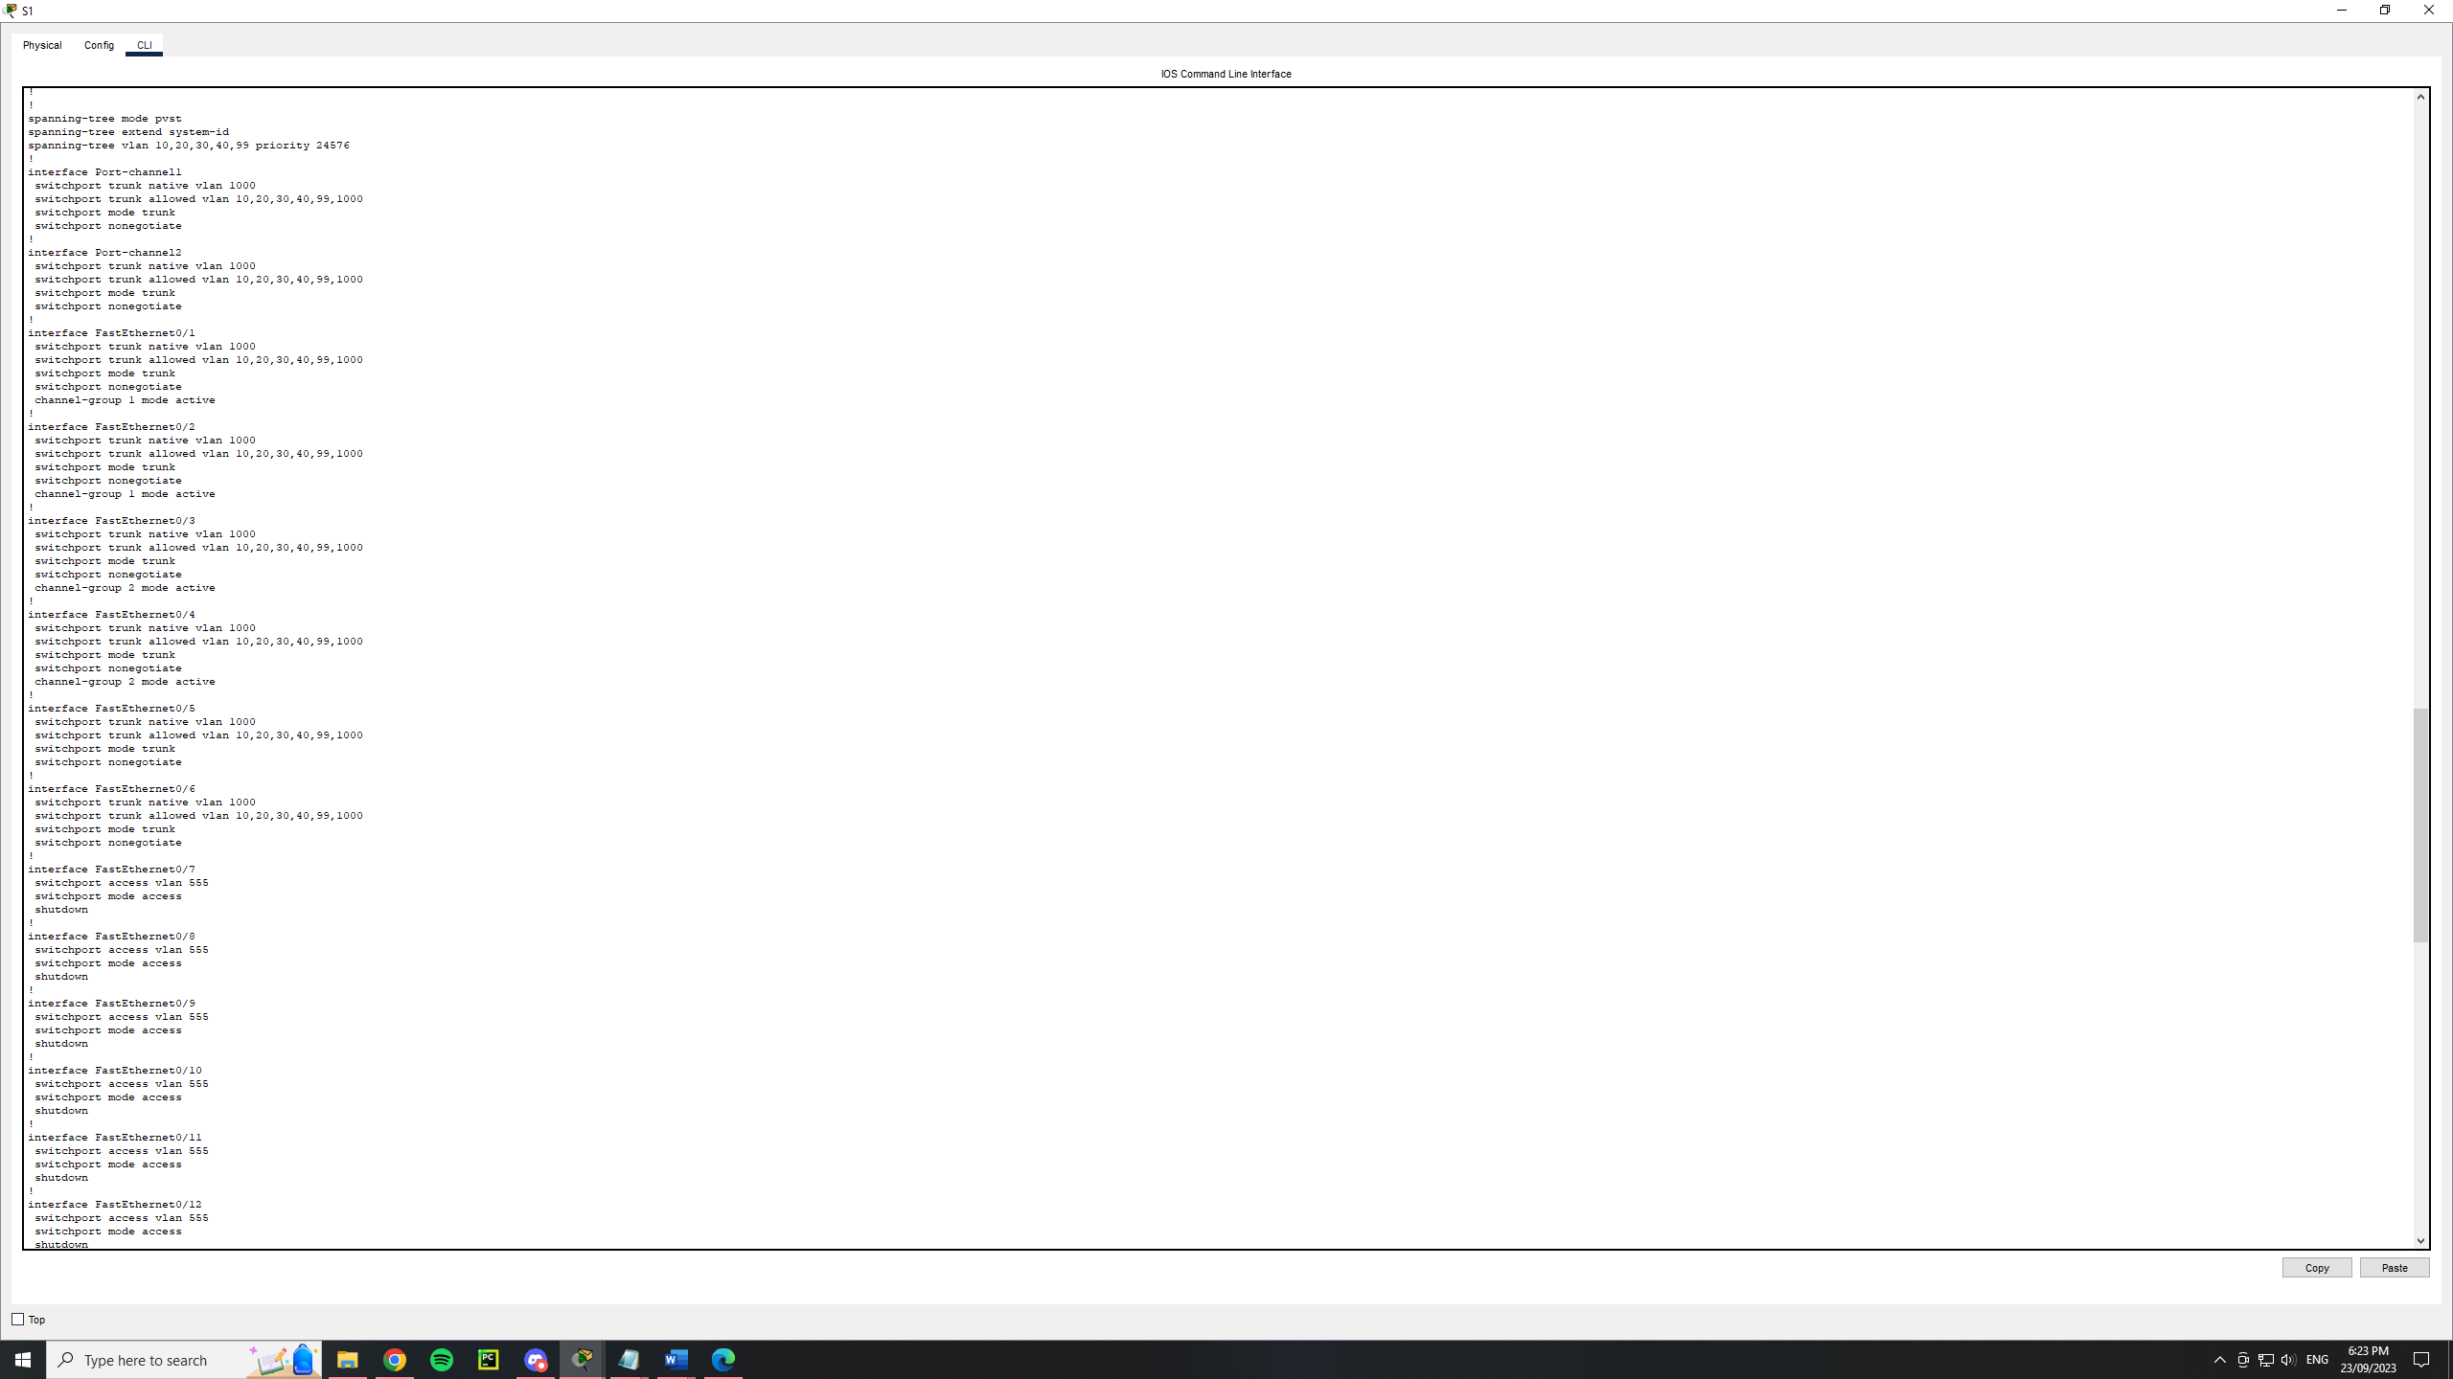

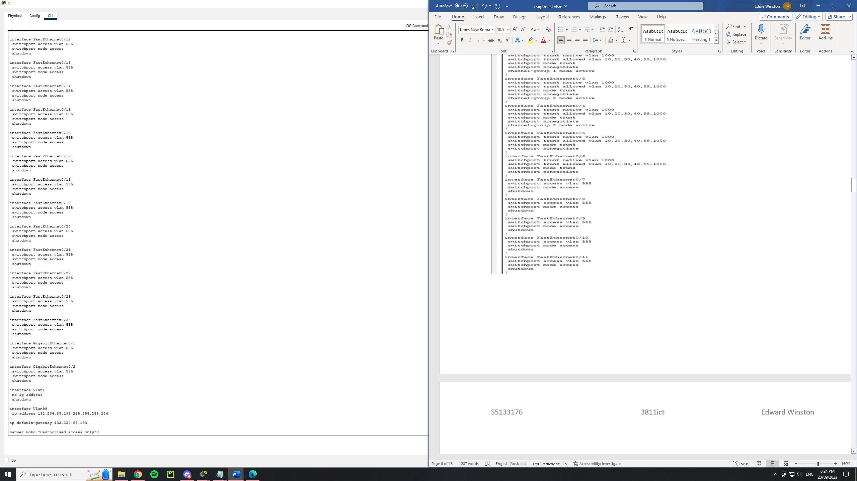

S2

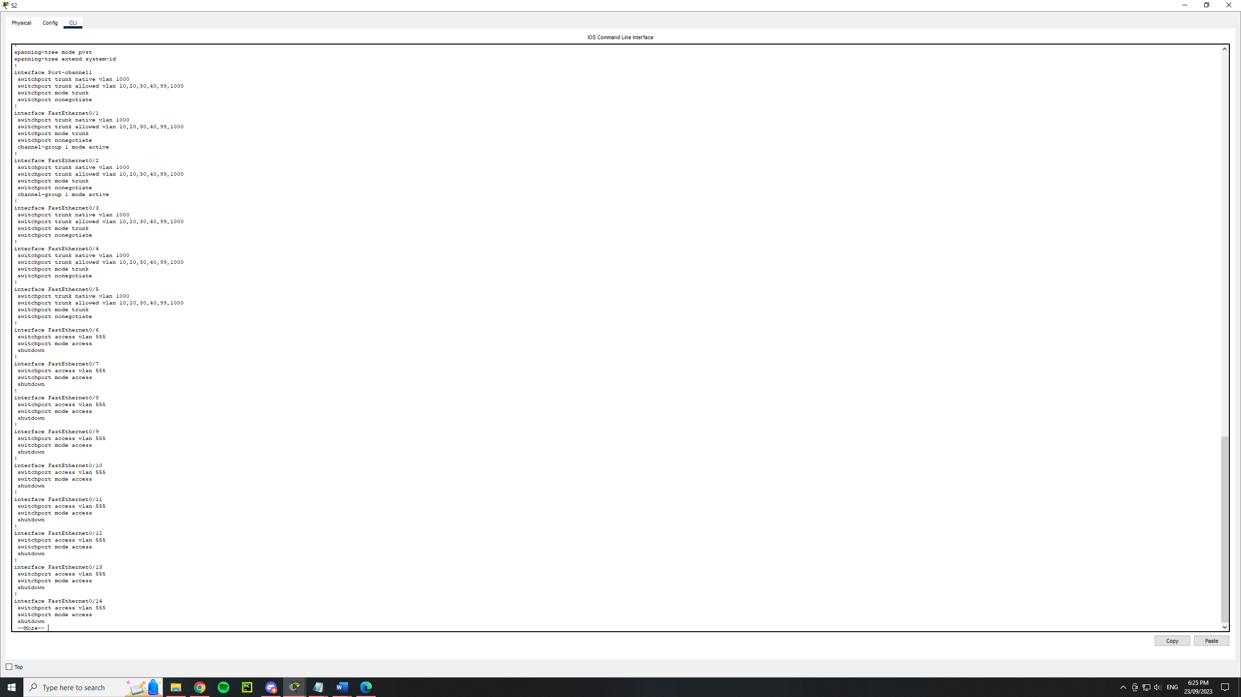

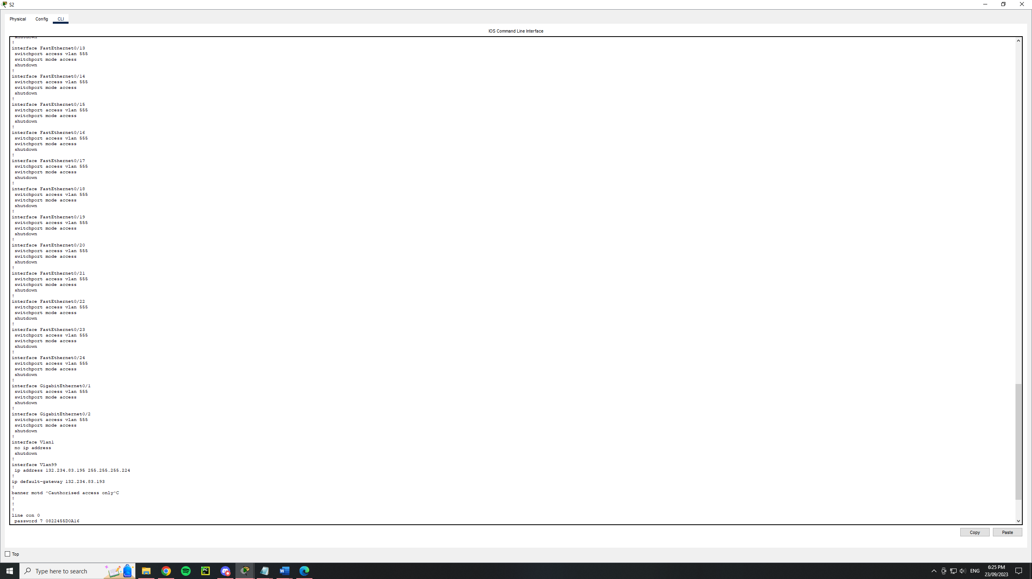

S3

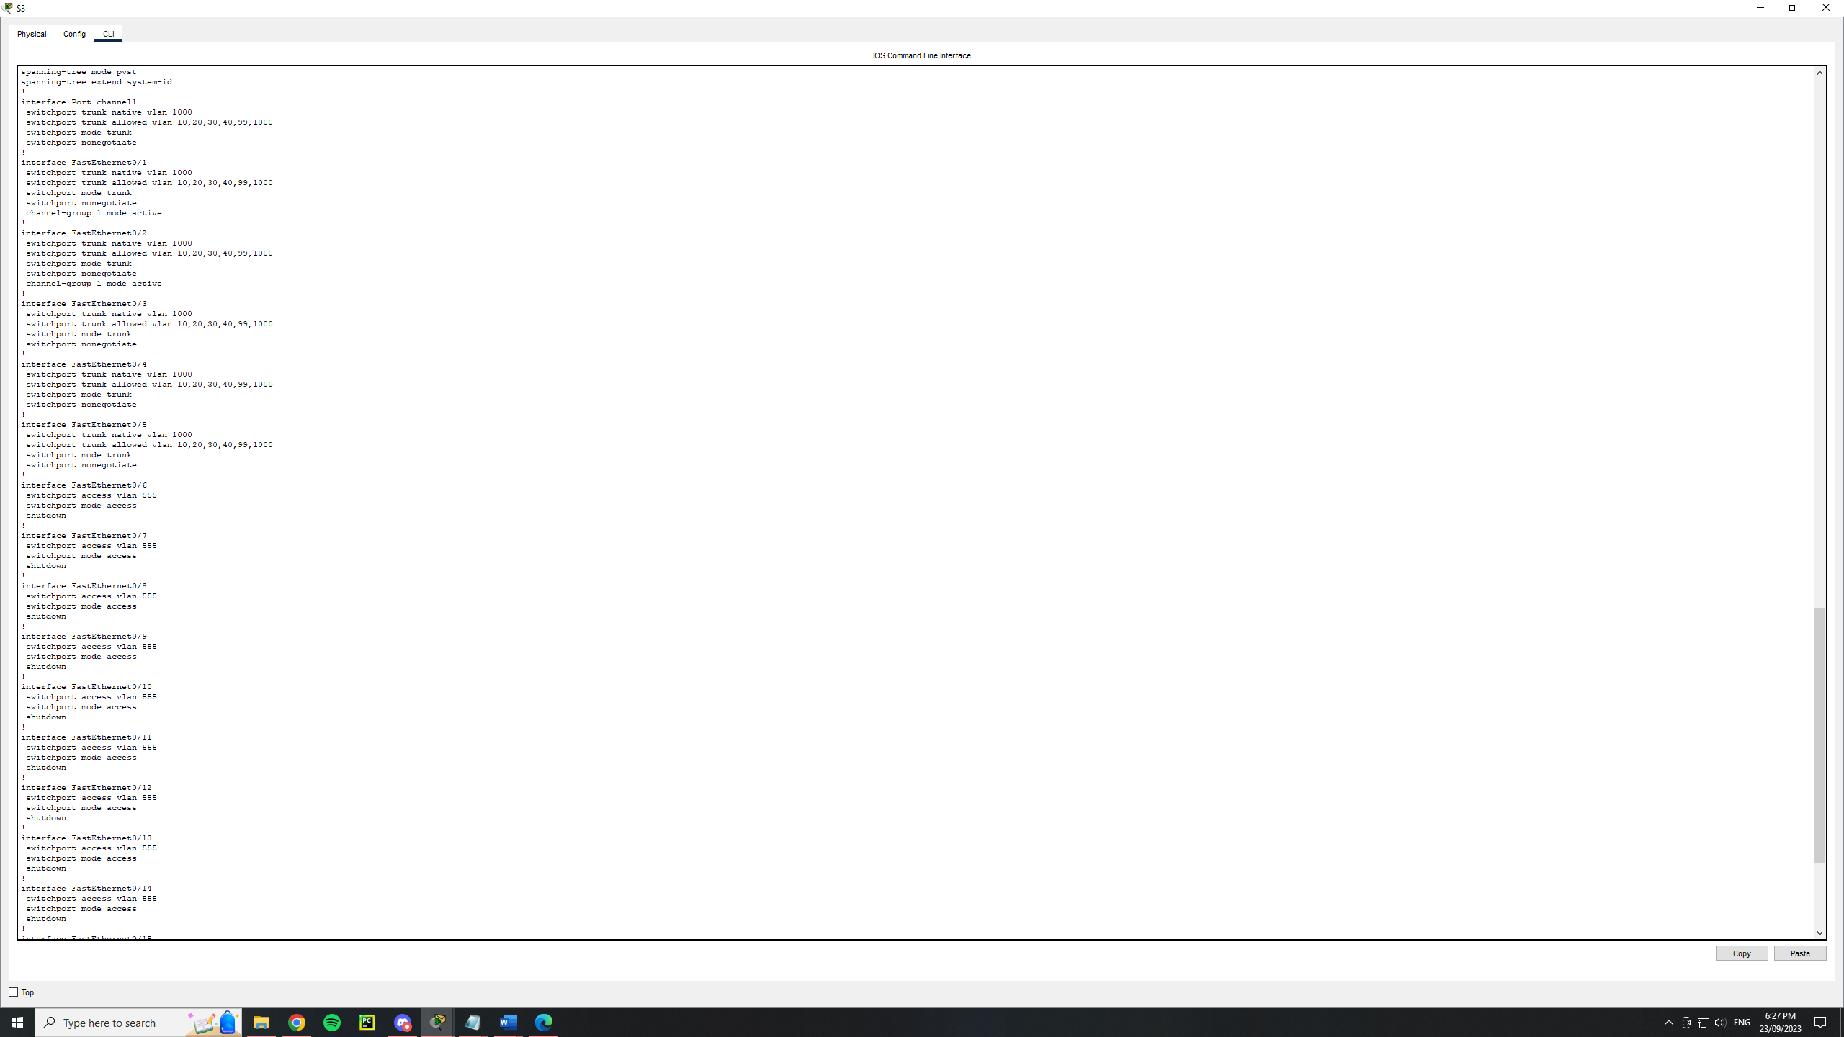

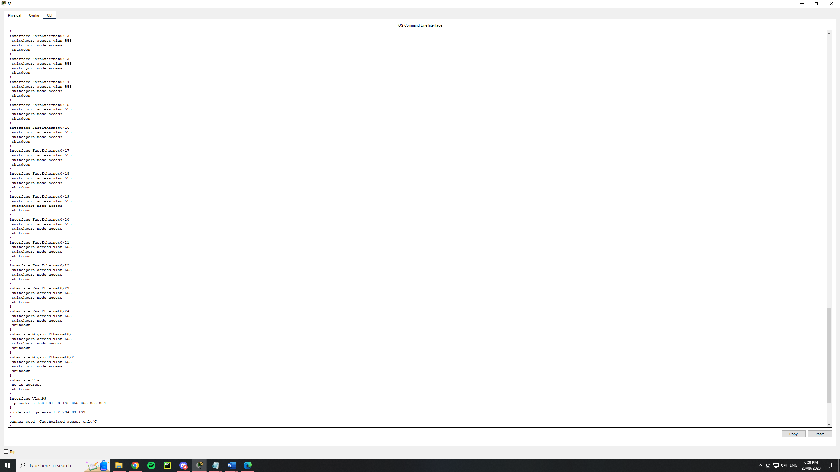

S4

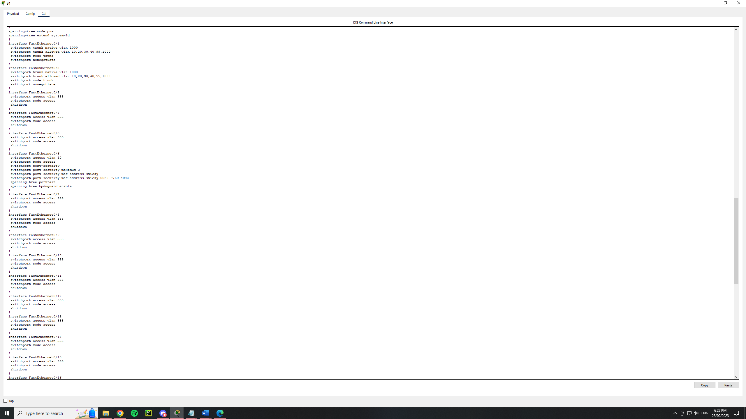

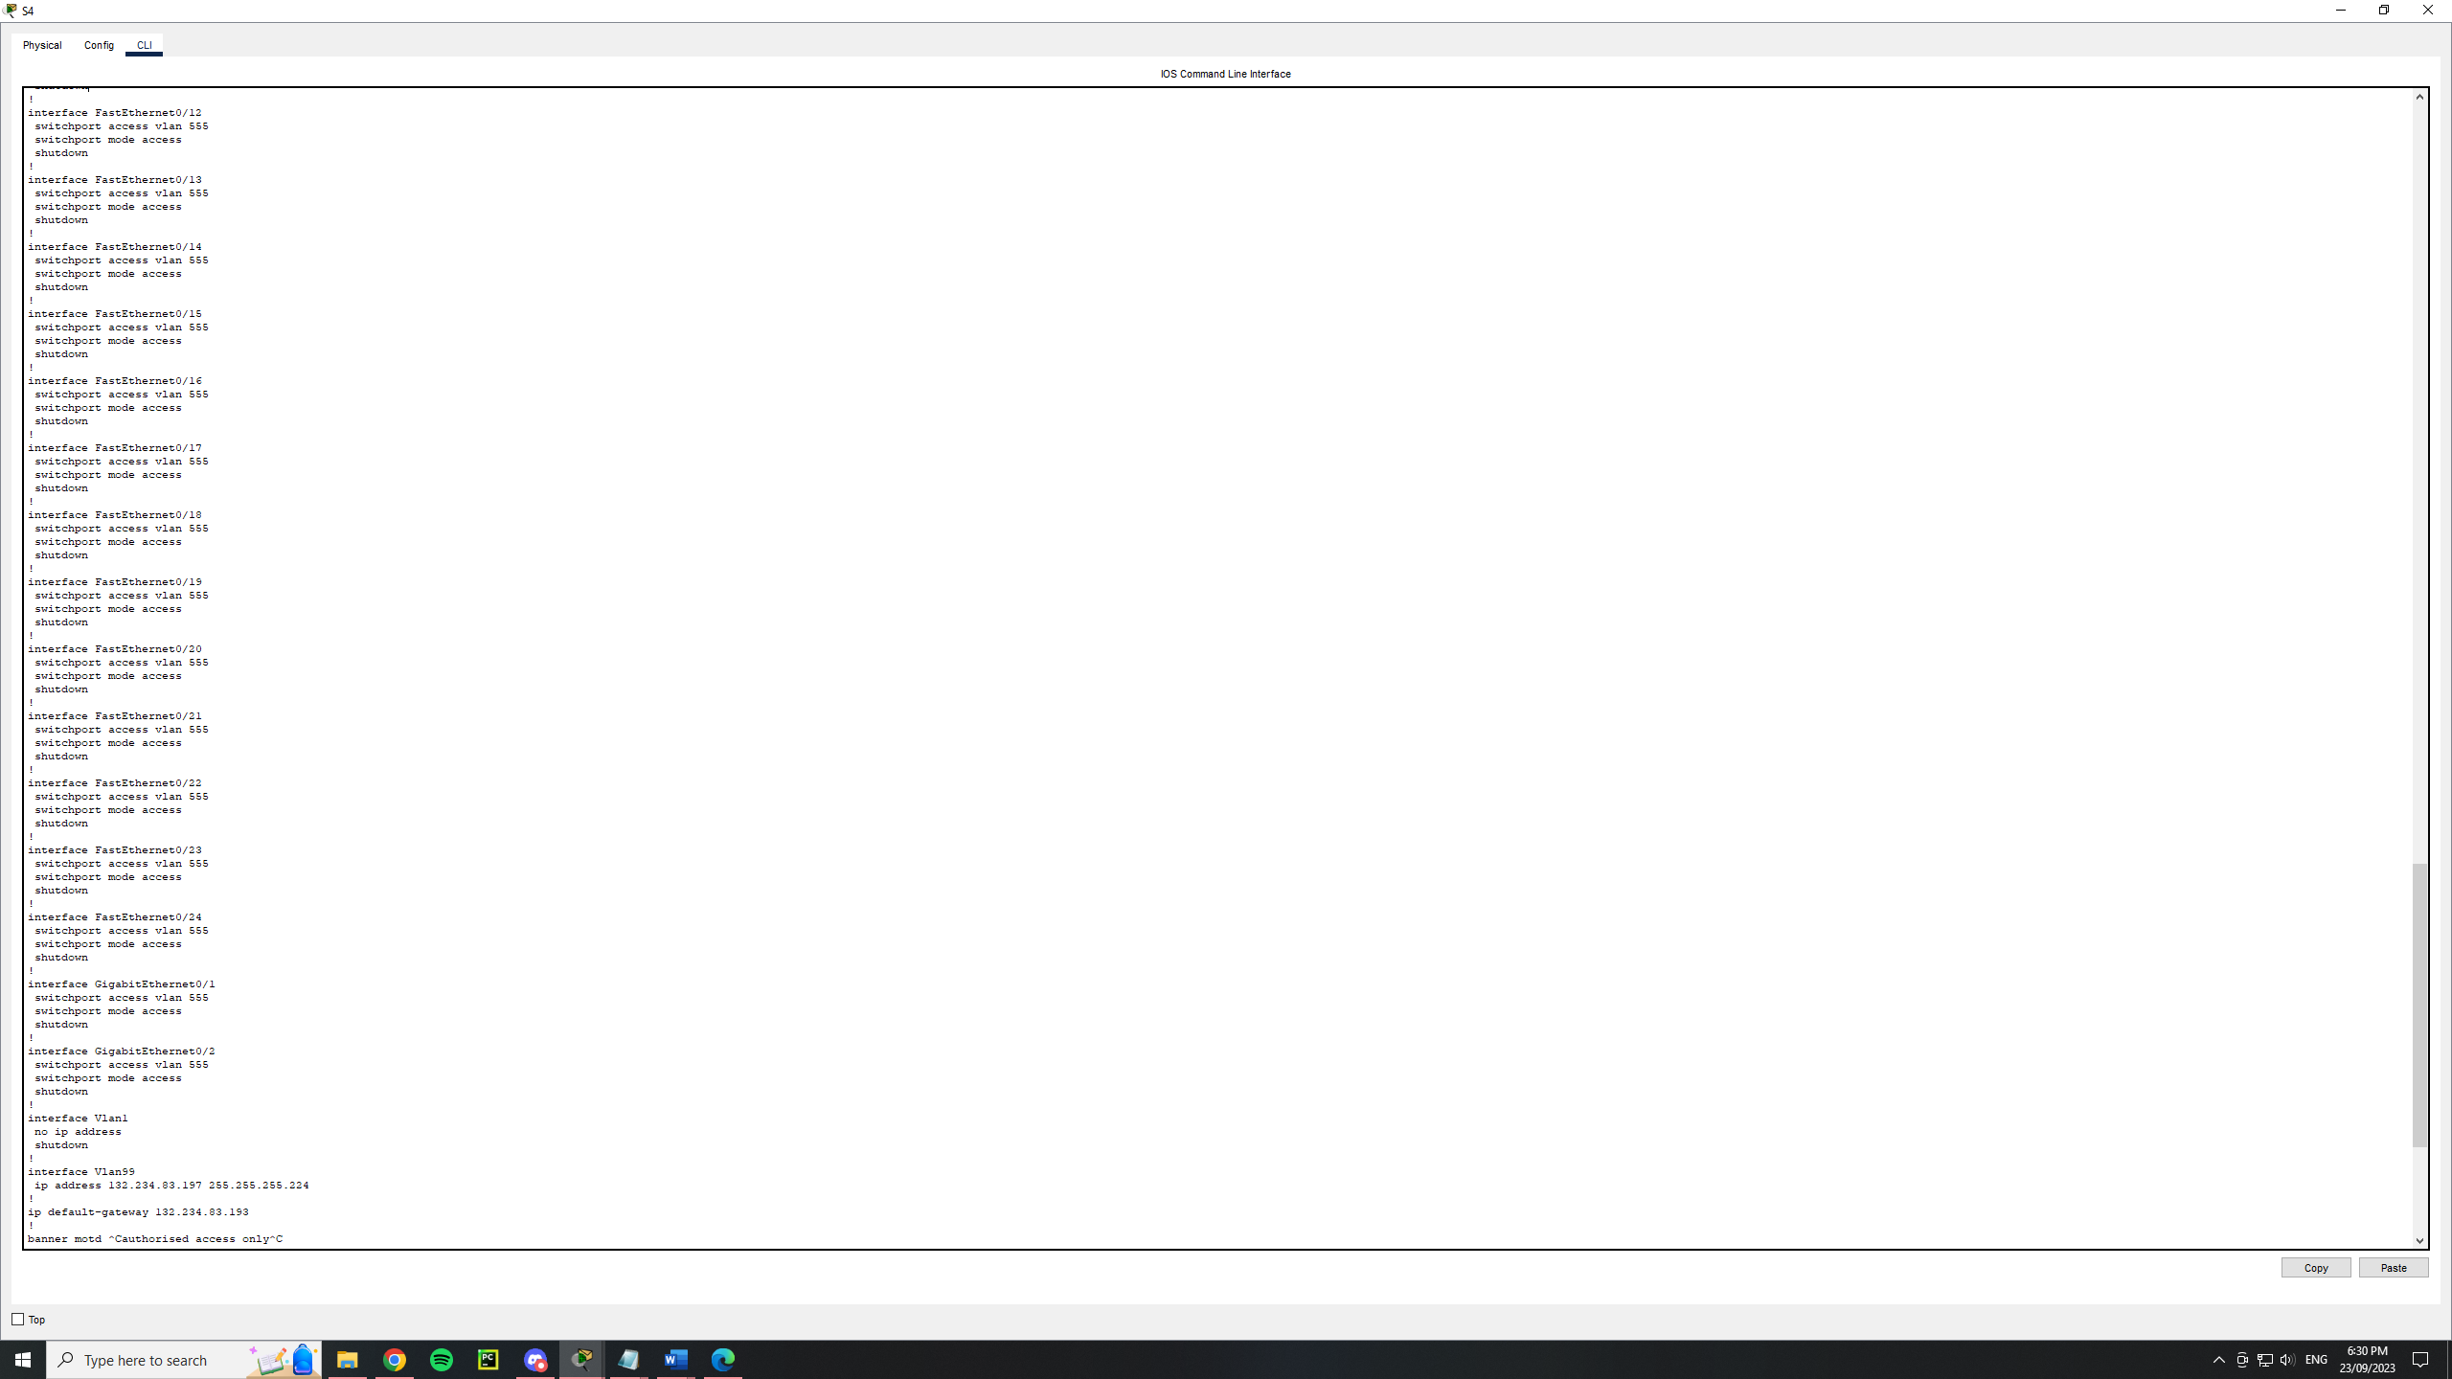

S5

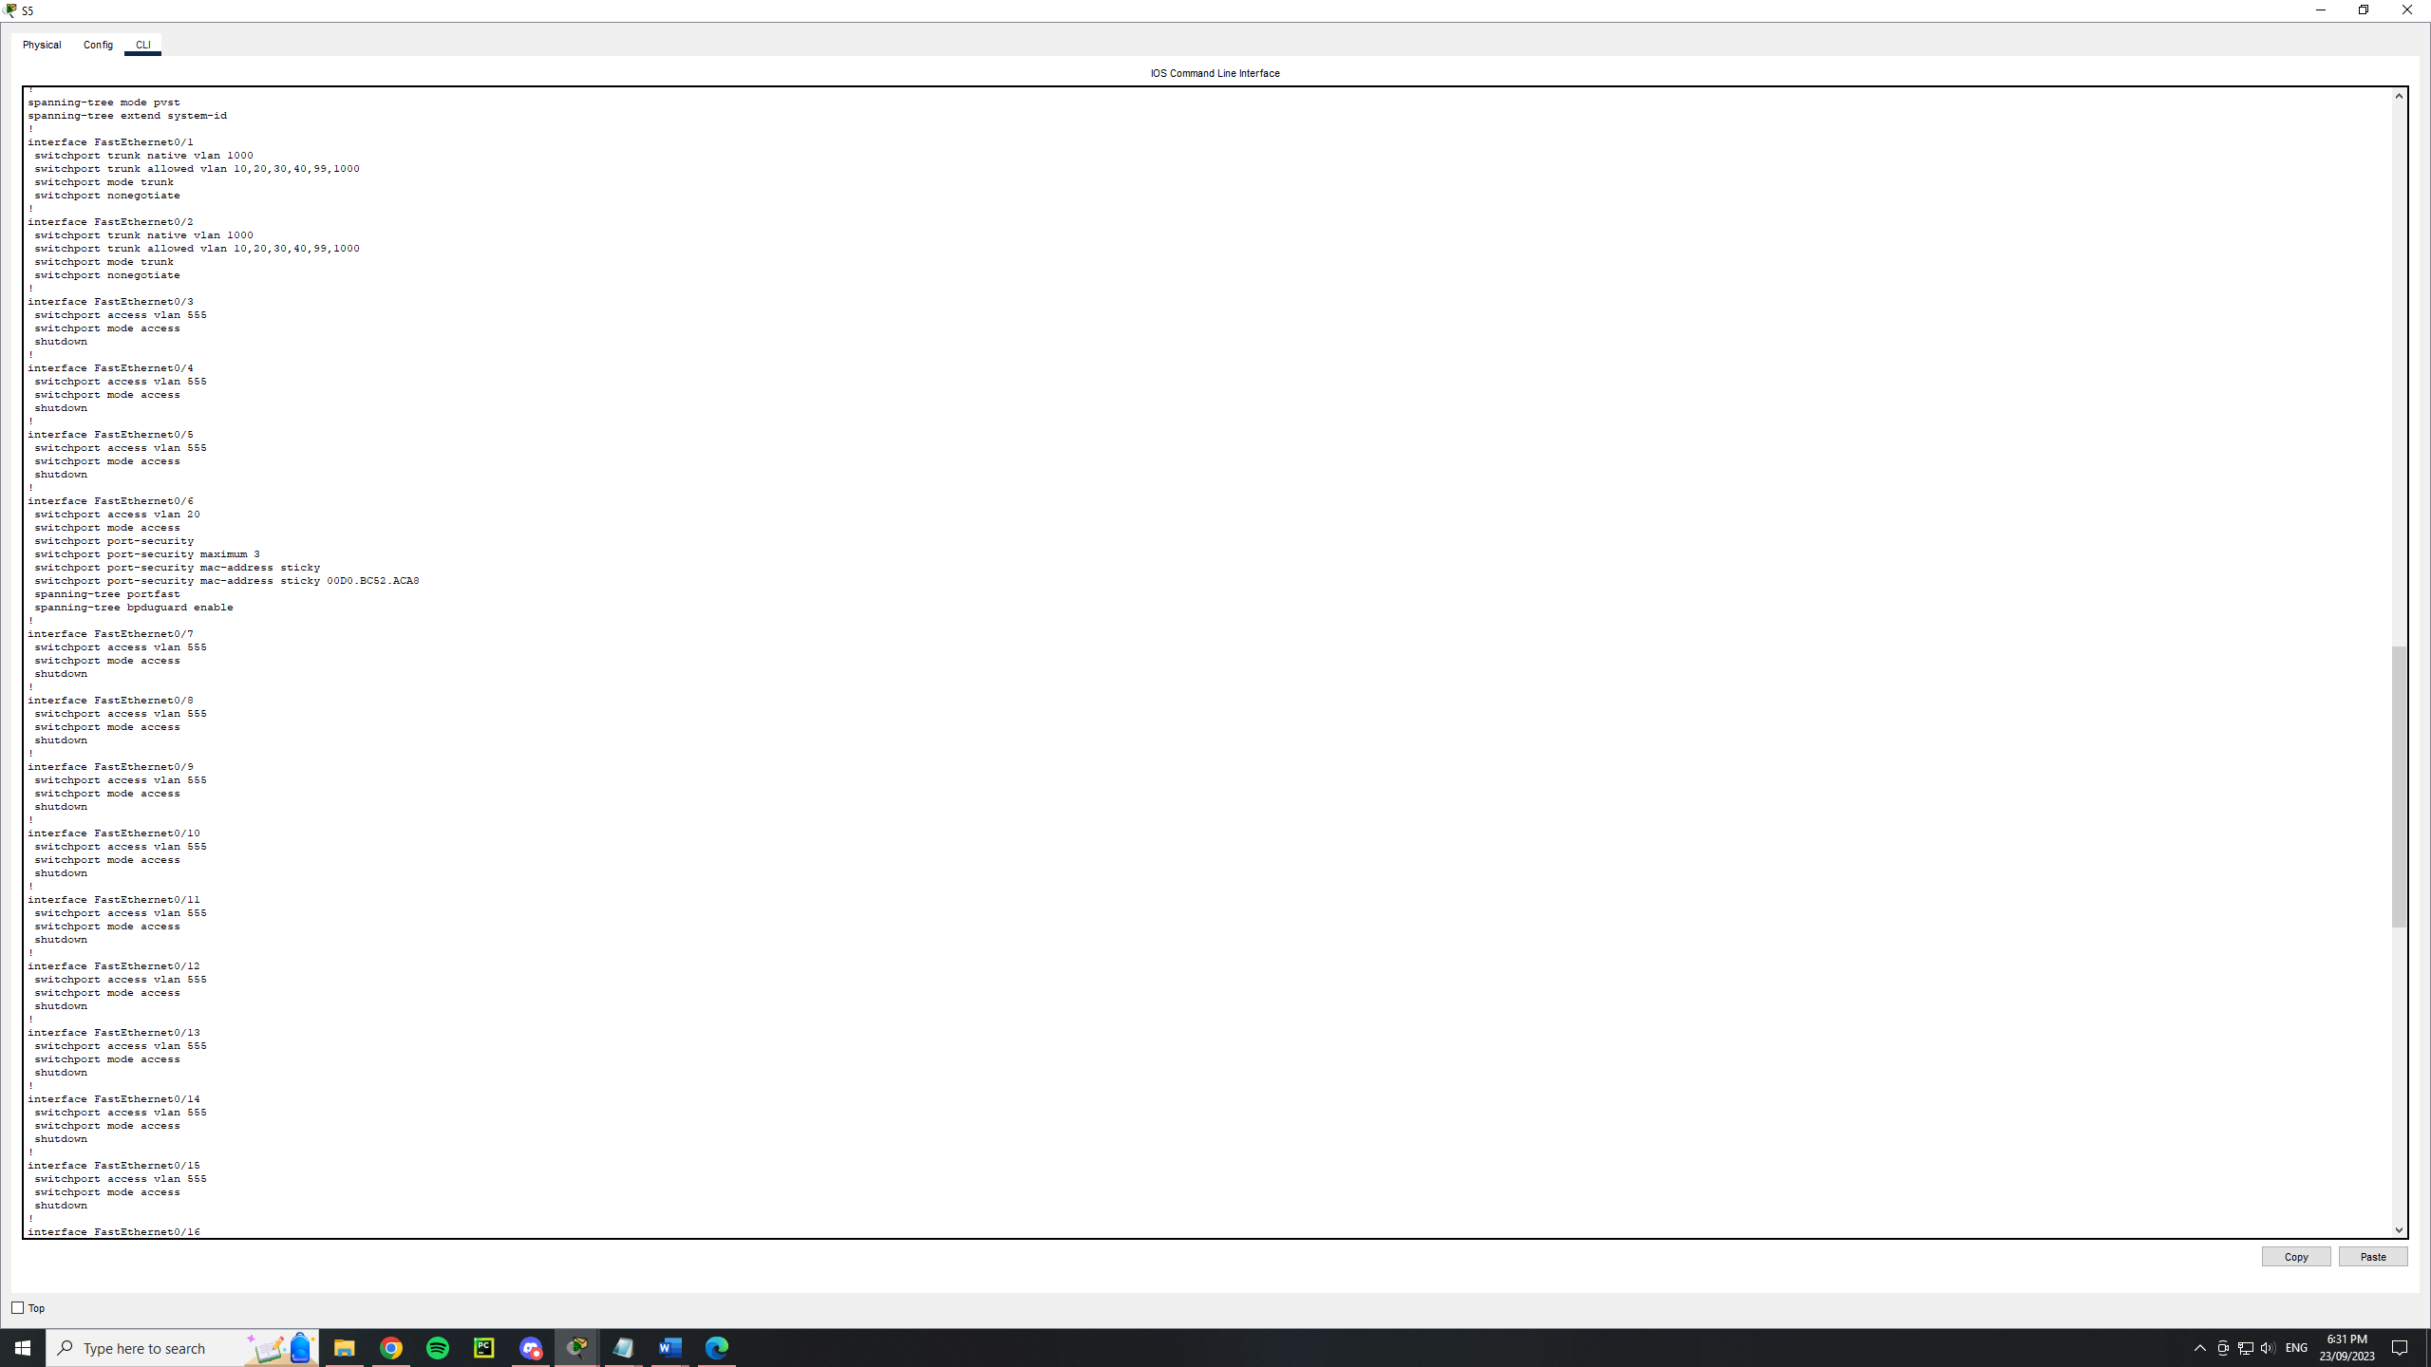

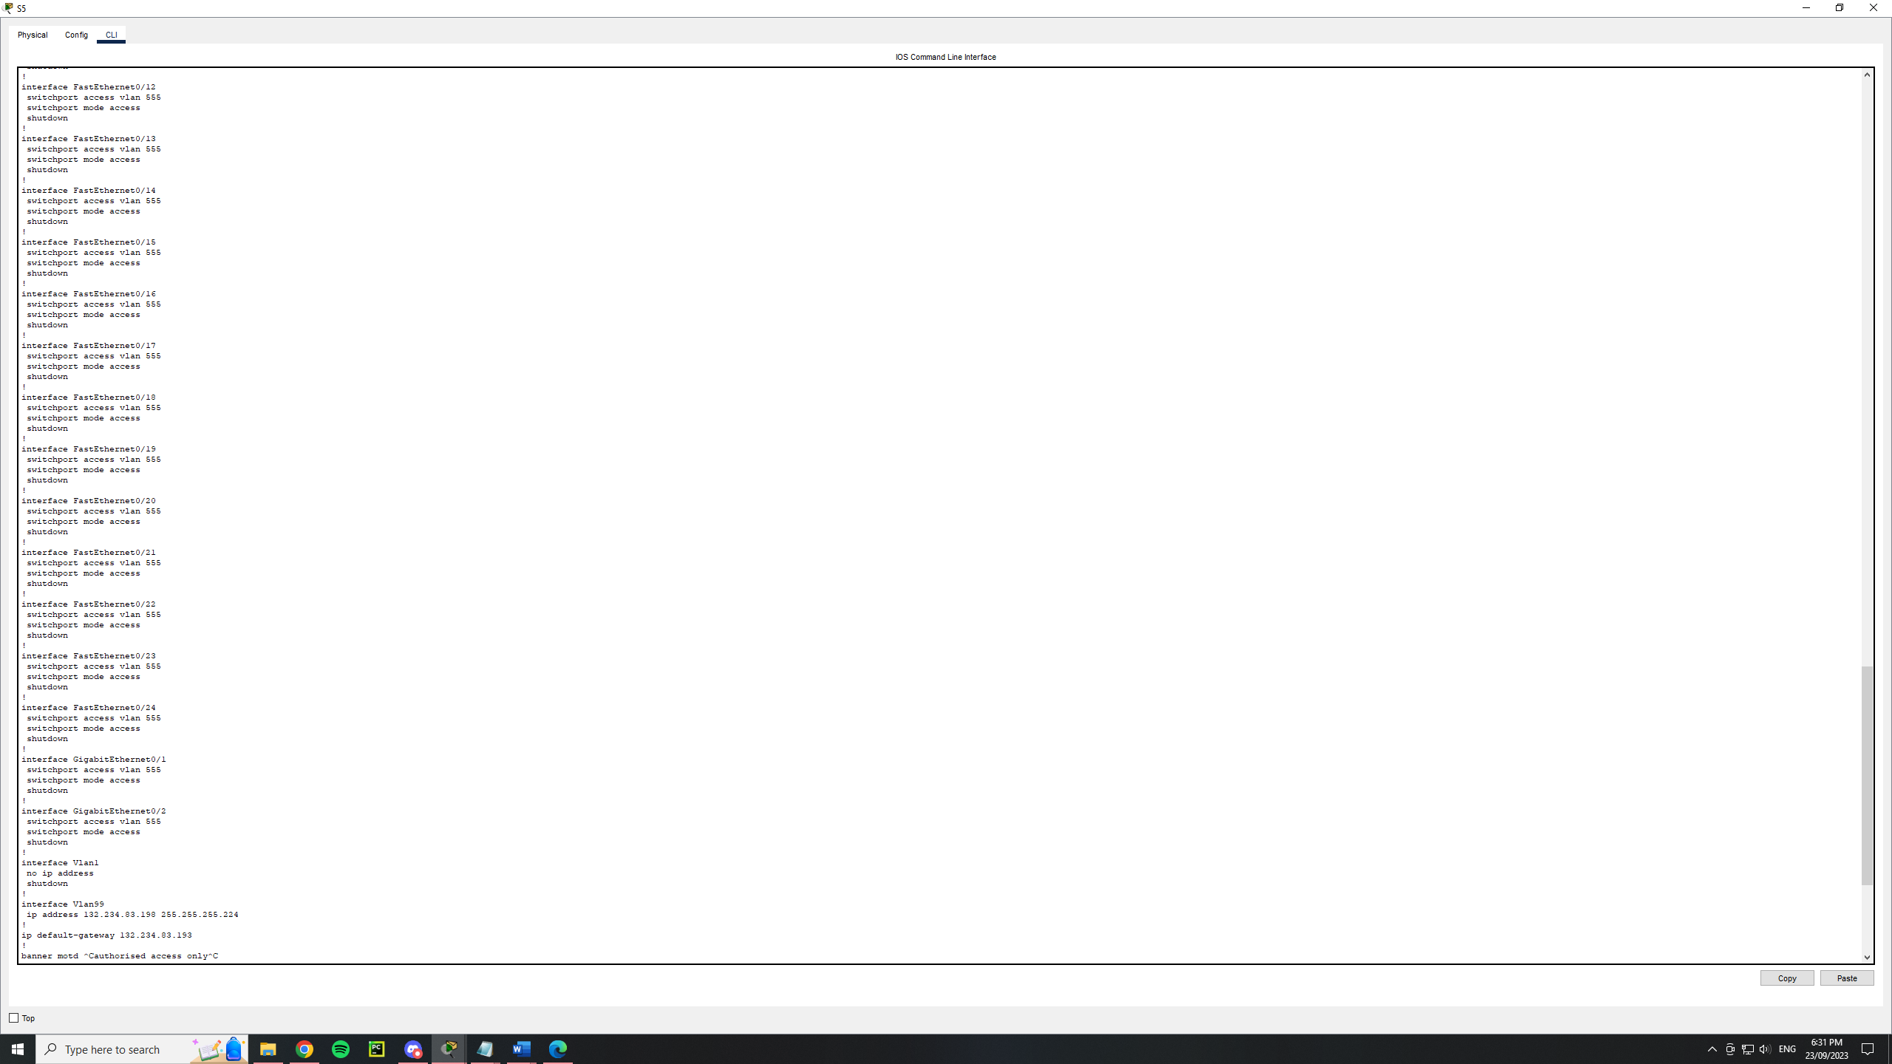

S6

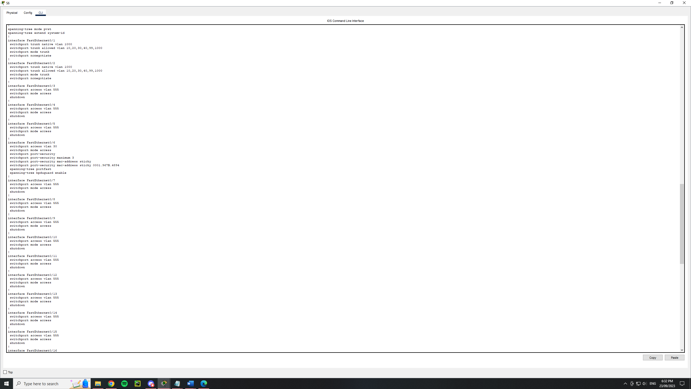

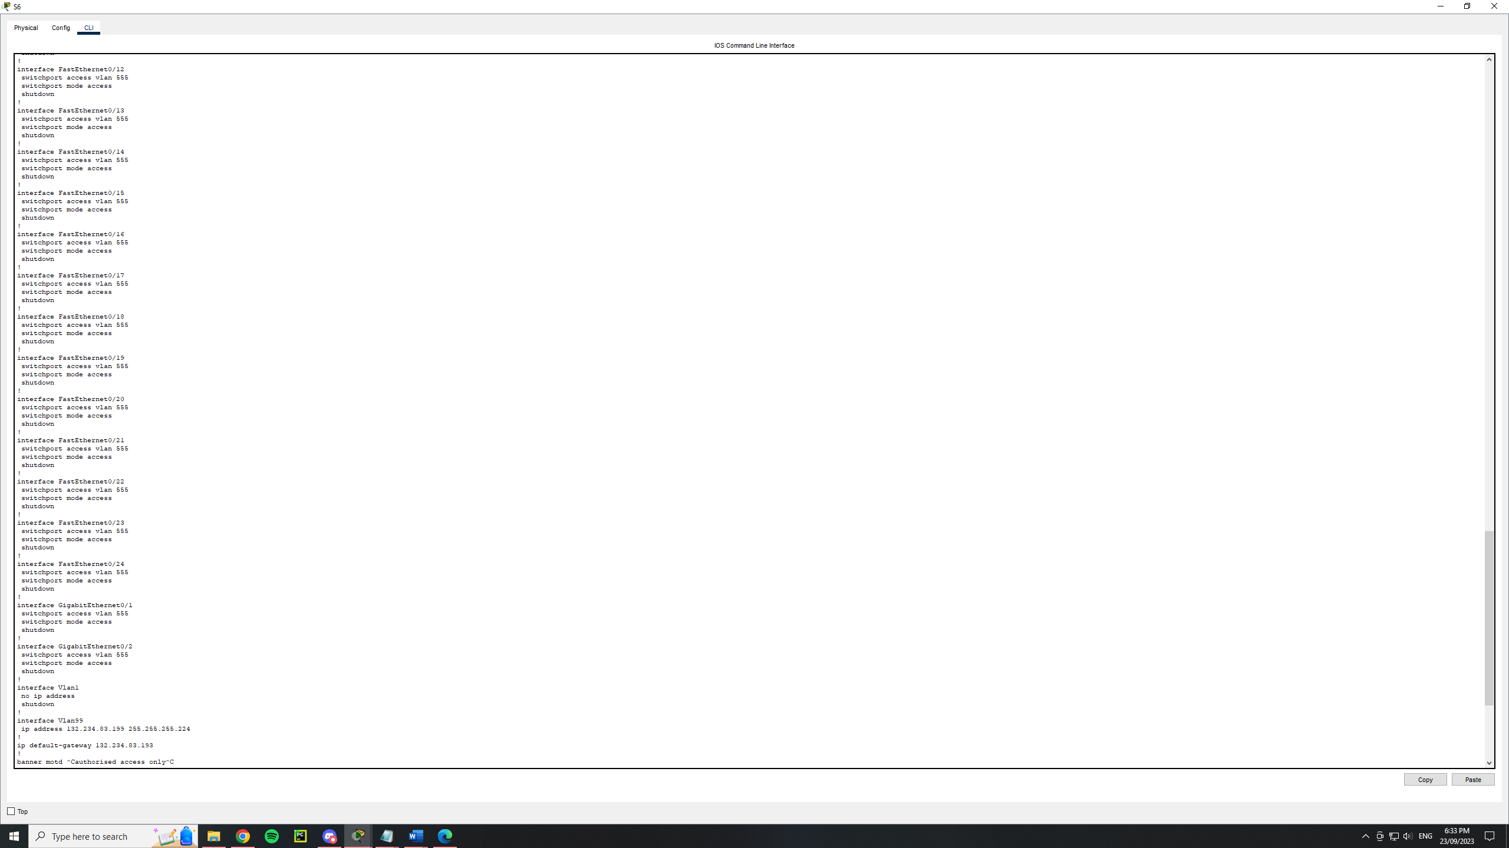

**Ether channel**

For the ether channels within this network they were all configured using lacp. This is because lacp is a protocol designed to control the combining of several physical ports together to form a single logical channel. It also has a negotiating feature using lacp packets. However this was disabled due to potential security risks.

On switch 1 (S1)

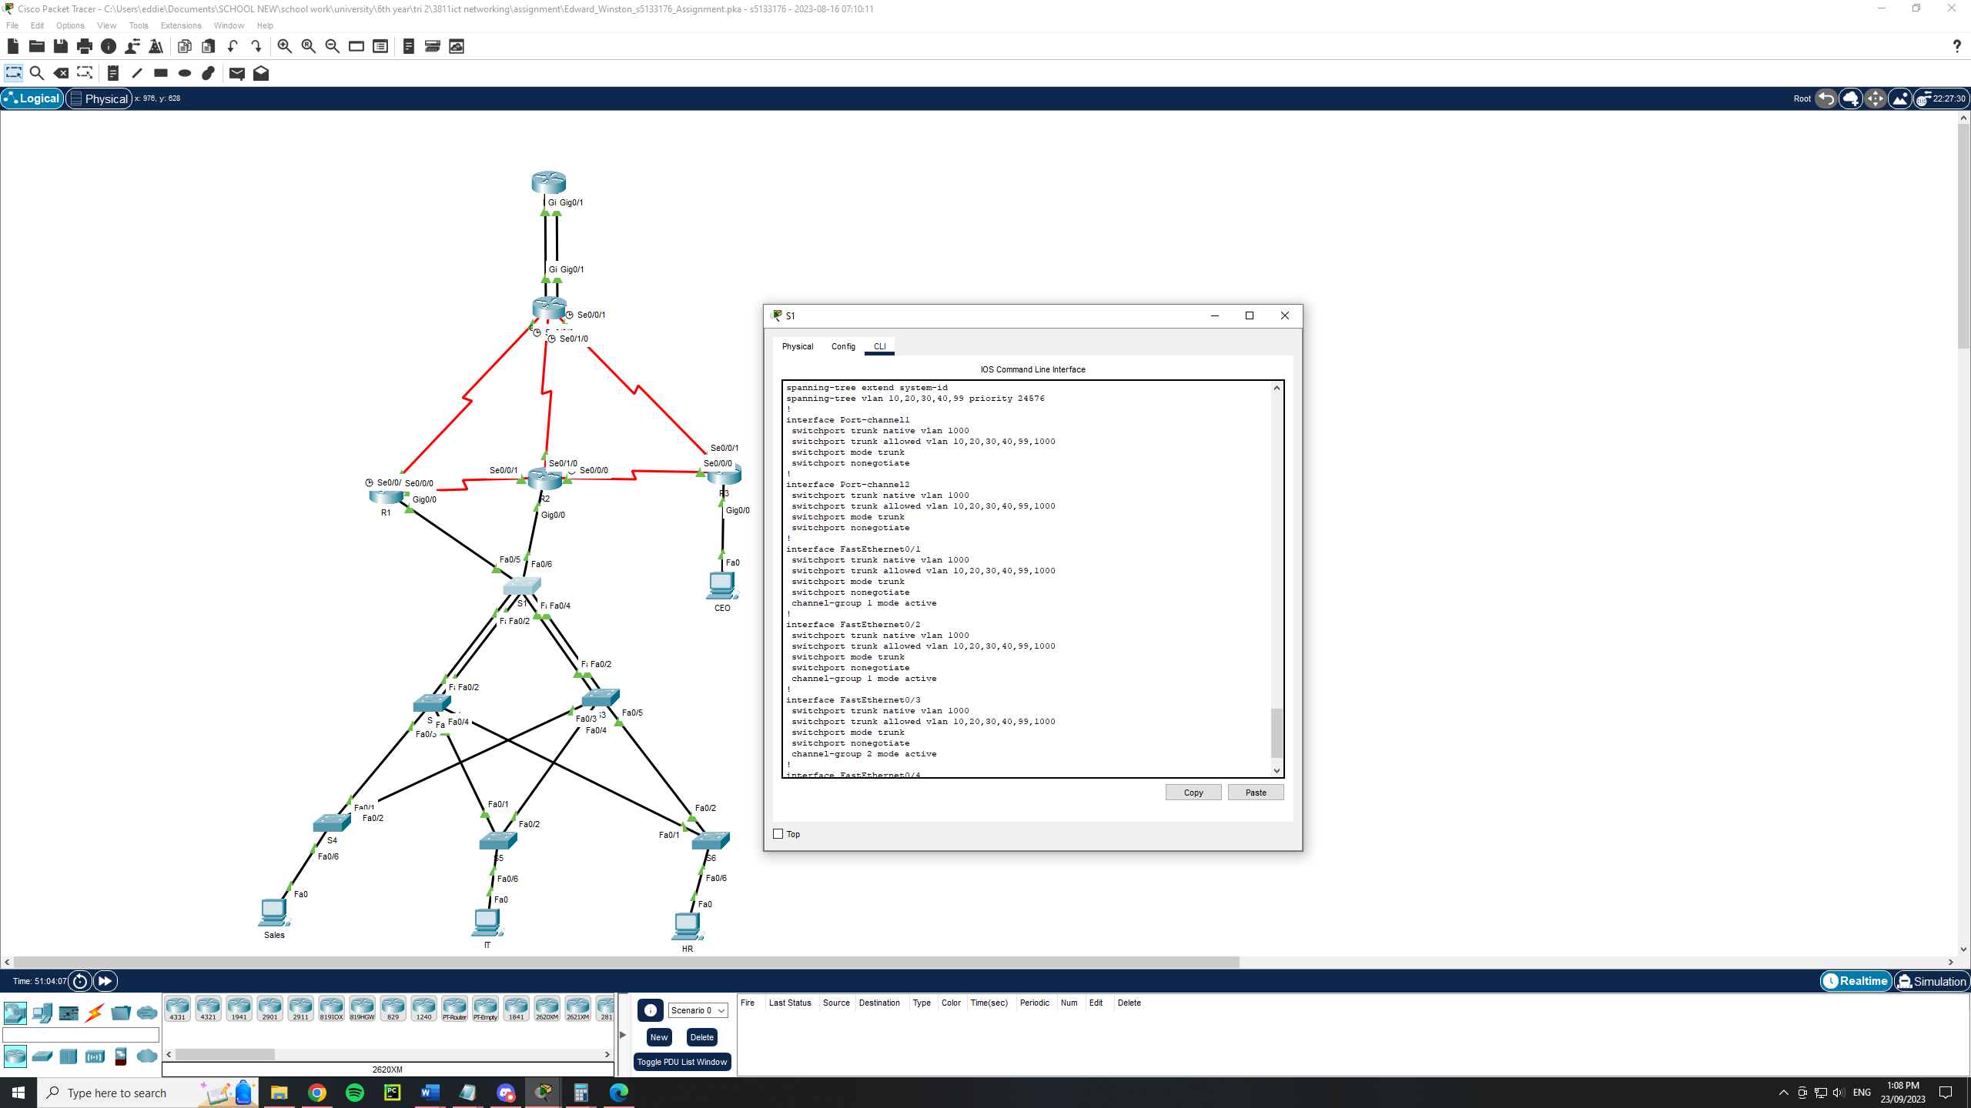

On switch 2 (S2)

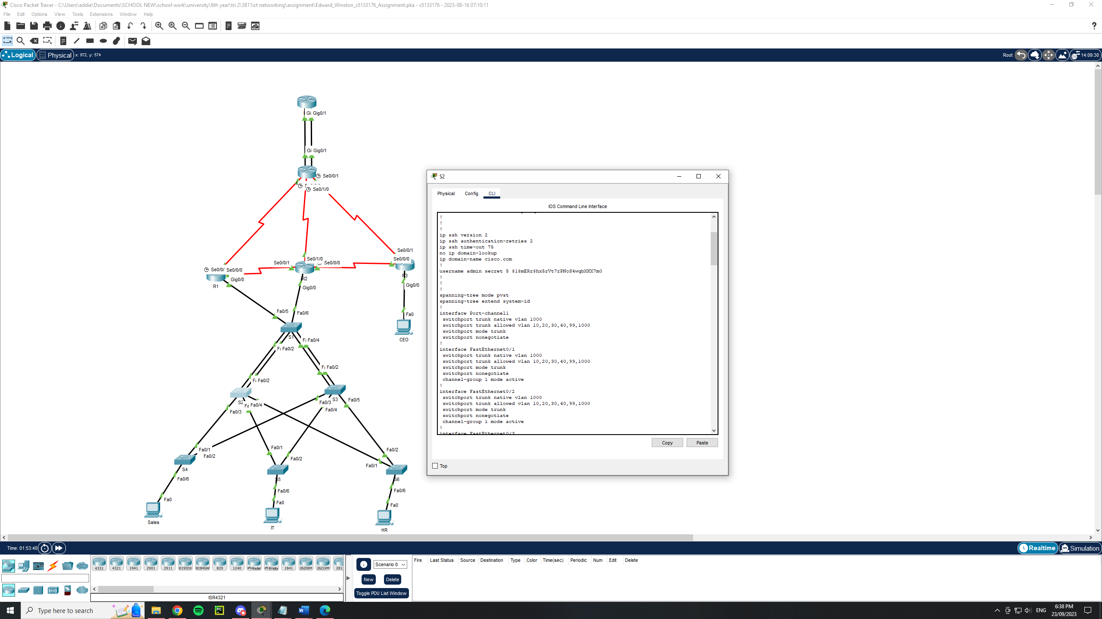

**STP config**

The spanning tree protocol uses switch 1 as the root bridge. This is because all the vlans will have to pass through the switch 1 in order to reach the routers. This can be seen below.

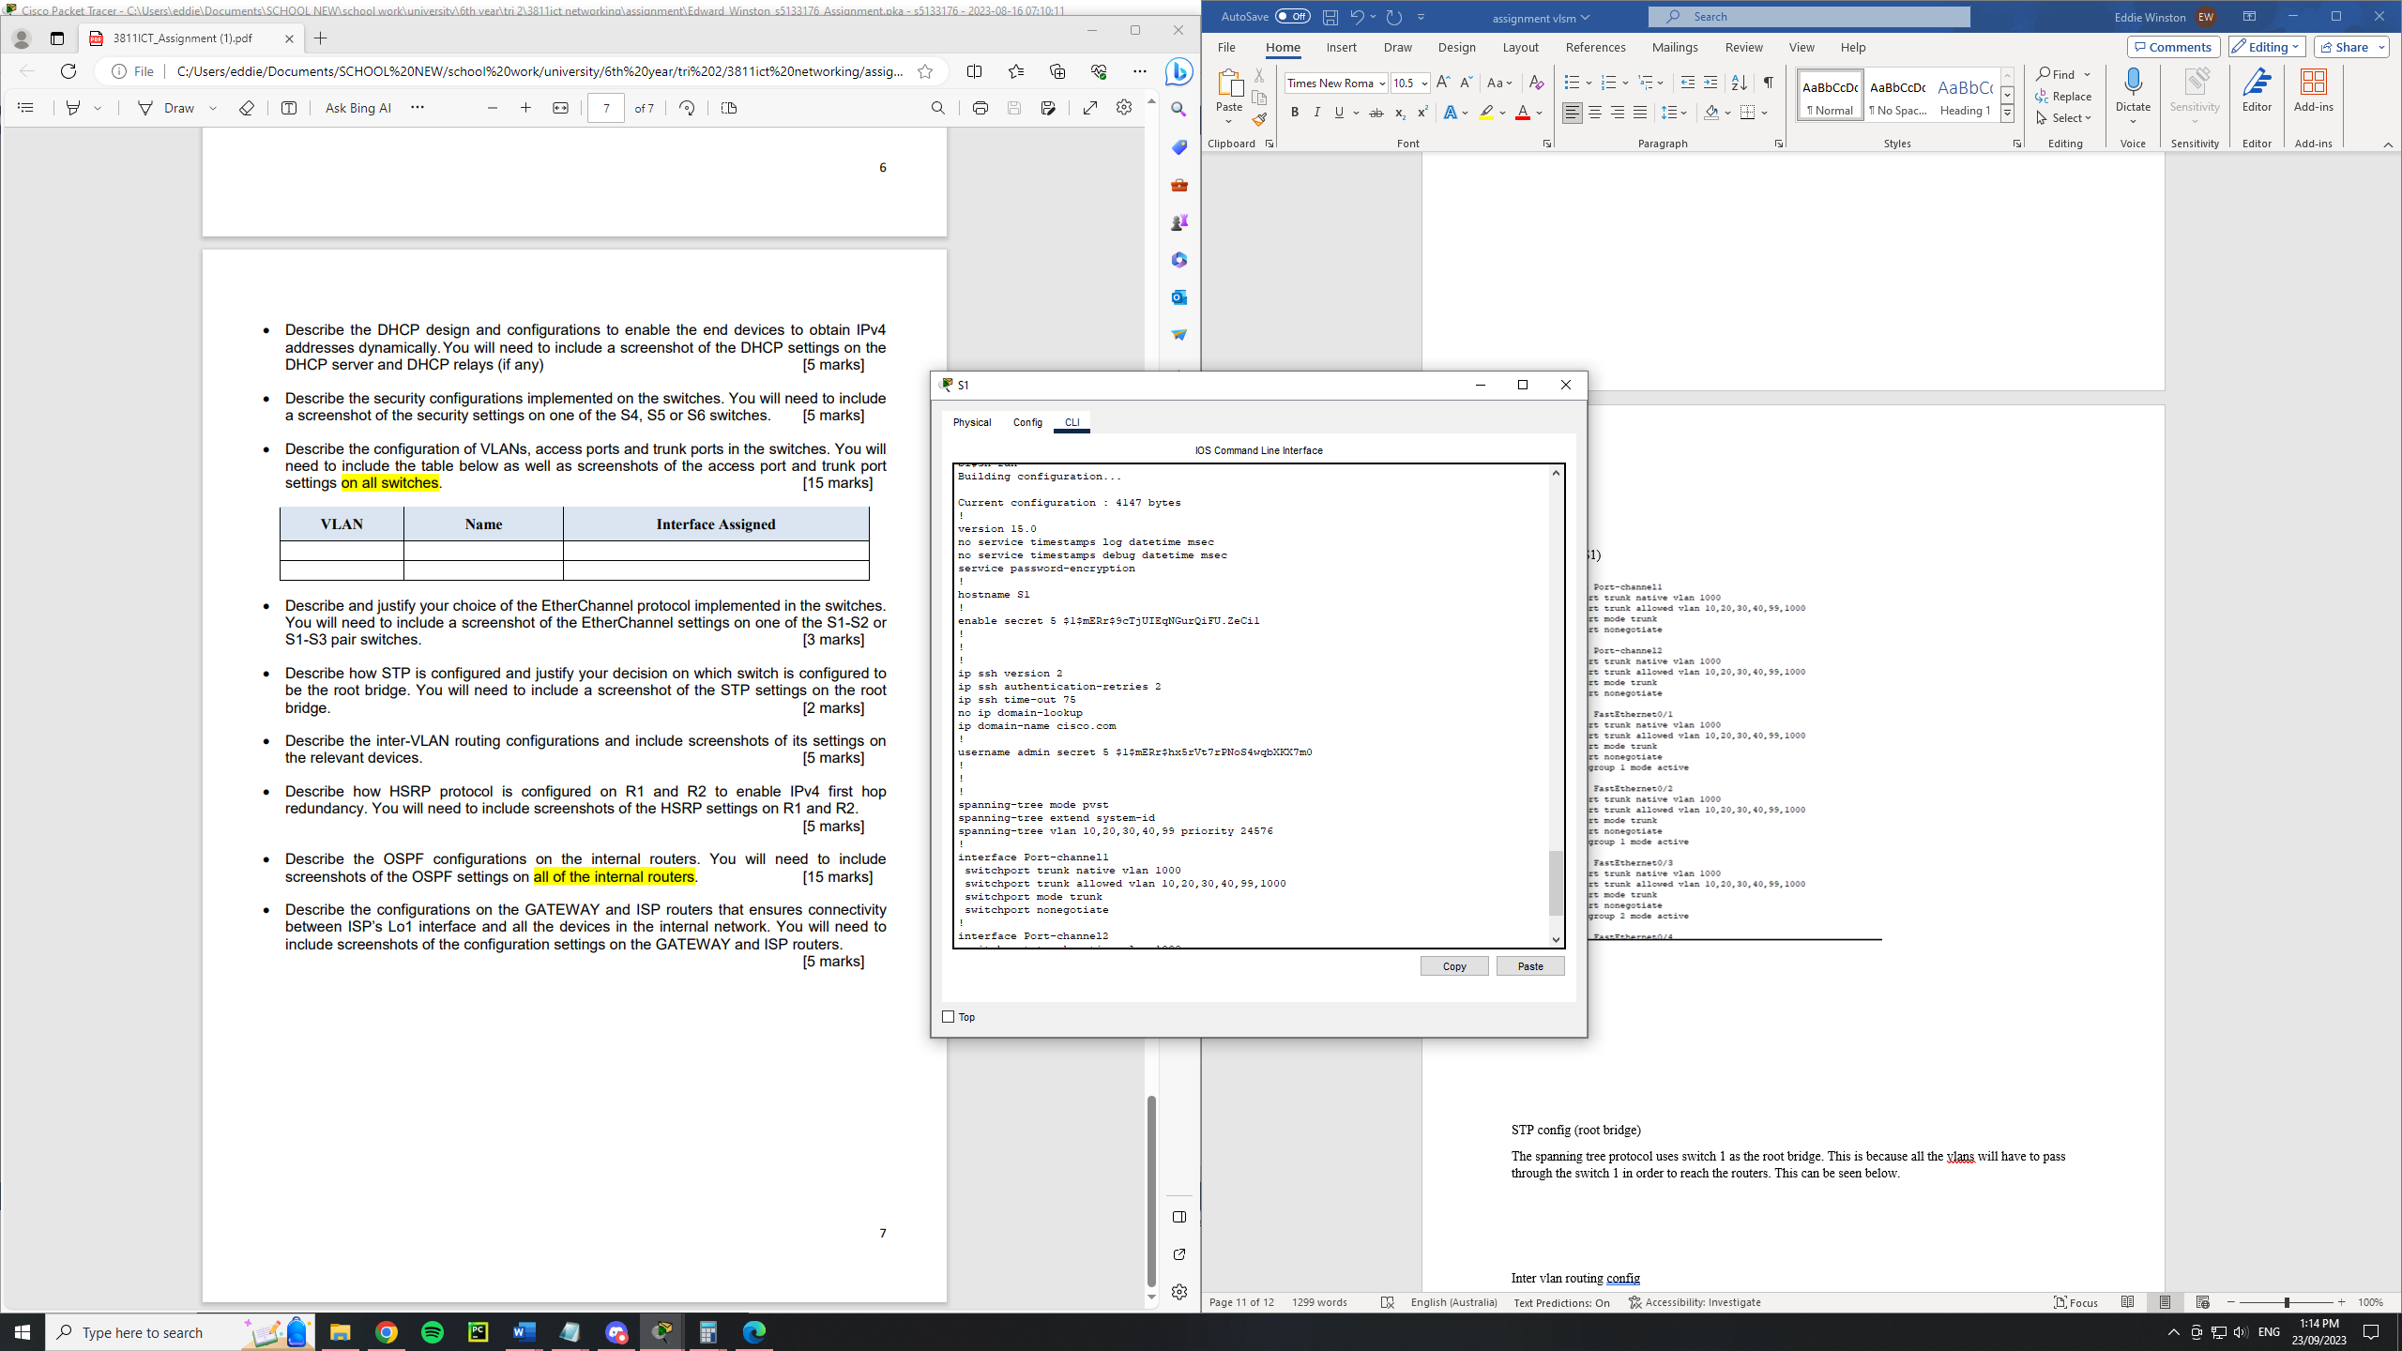

**Inter-Vlan Routing**

In order to achieve interval routing r1, r2 and r3 had been configured with encapsulation. R1 and R2 was configured with vlans 10, 20, 1000 and 30. This can be seen below:

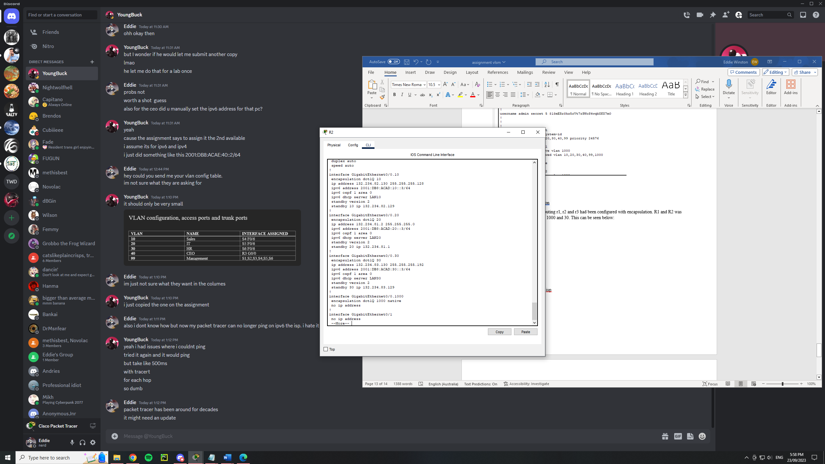

Routers 1 and 2 were configured with these vlans as these vlans connect to the network through them.

For router 3 it was configured with vlans 40 and 1000. This can be seen below:

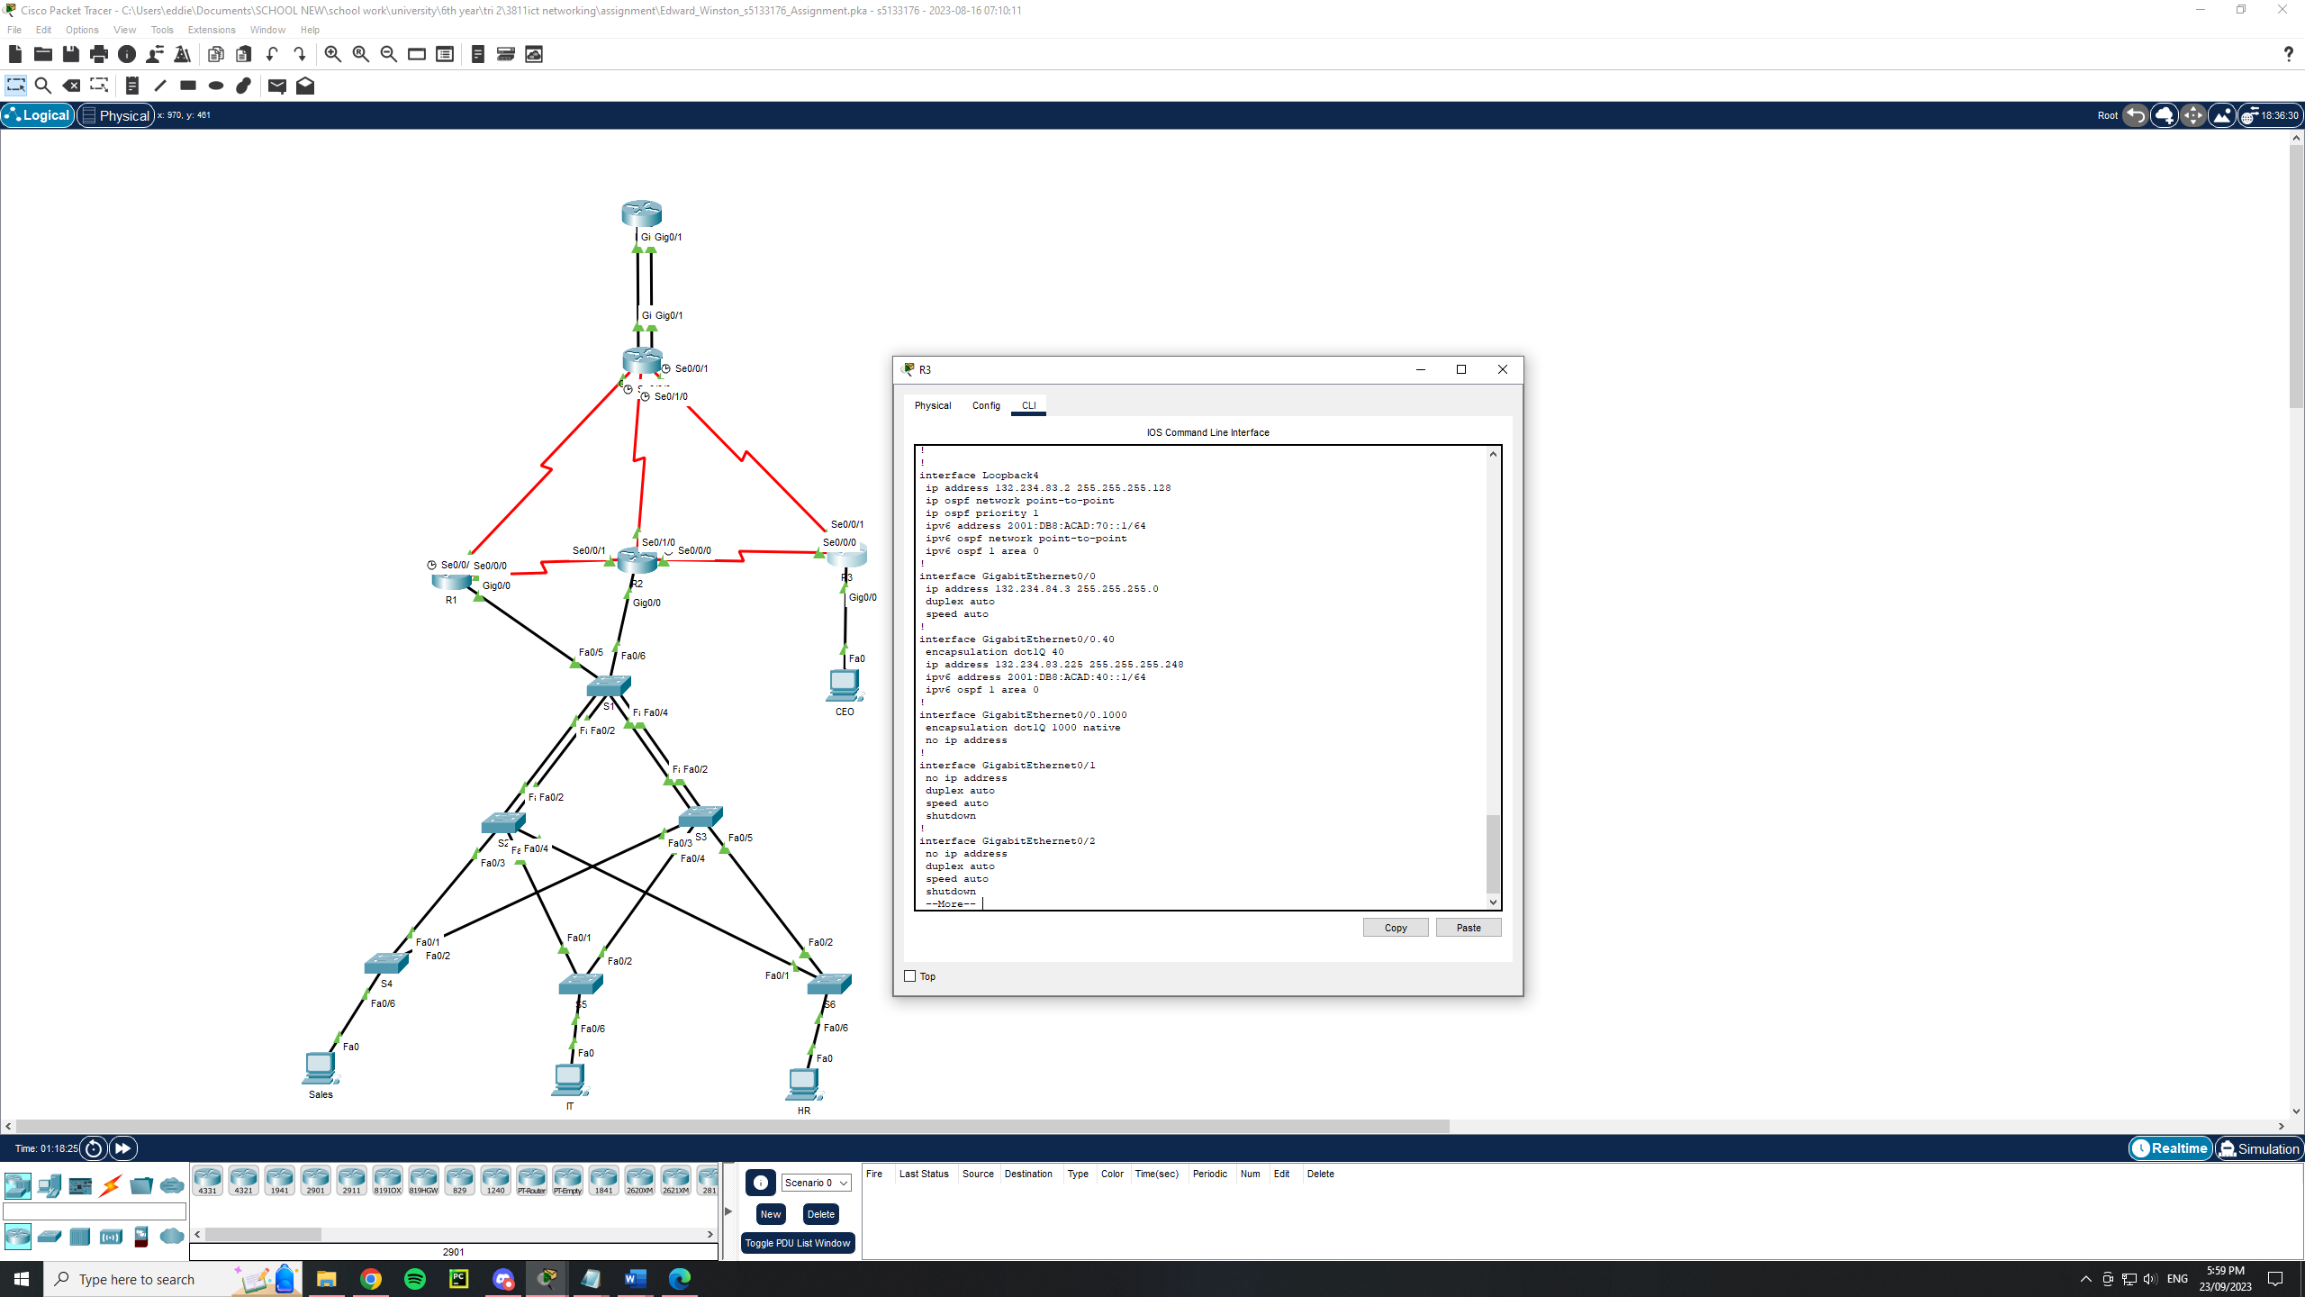

R3 had the CEO encapsulation because the ceo pcs were directly connected to this router.

**HSRP**

The HSRP was configured on router one and two. The configuration for r1 can be seen below:

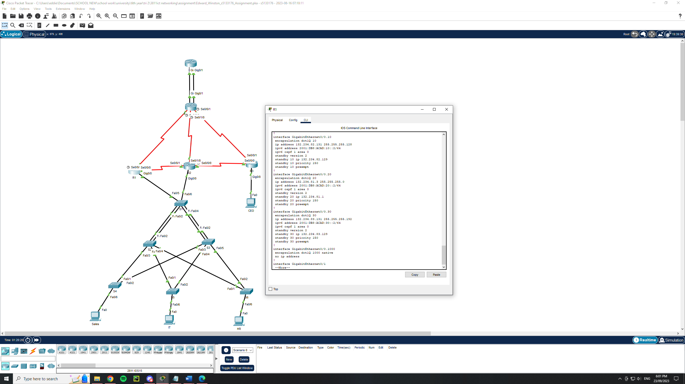

For r2

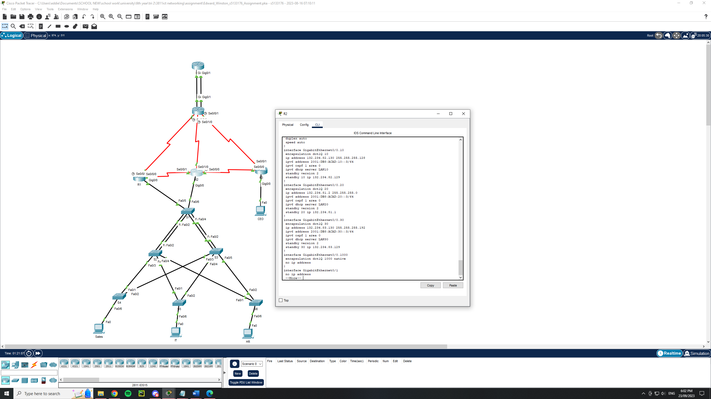

These routers were configured with the hsrp as these routers housed the encapsulation of the vlan 10, 20 and 30. On r1 there is a standby priority configured at 150. This is to ensure that r1 is the secondary choice as r2 is not configured with a standby priority which means it has the default of 100. R2 was the primary as it is the location of the dhcp server.

**OSPF**

A single area ospf was used for this network. It consists of all the ruters beng assigned to area 0. The ospf on r1, 2 and 3 advertised the networks inside their encapsulation ie g0/0.10. this was because these act as independent connections. Due to these acting as independent connections each vlan will also need to be set to passive. These routers also advertised their serial connections.

R1

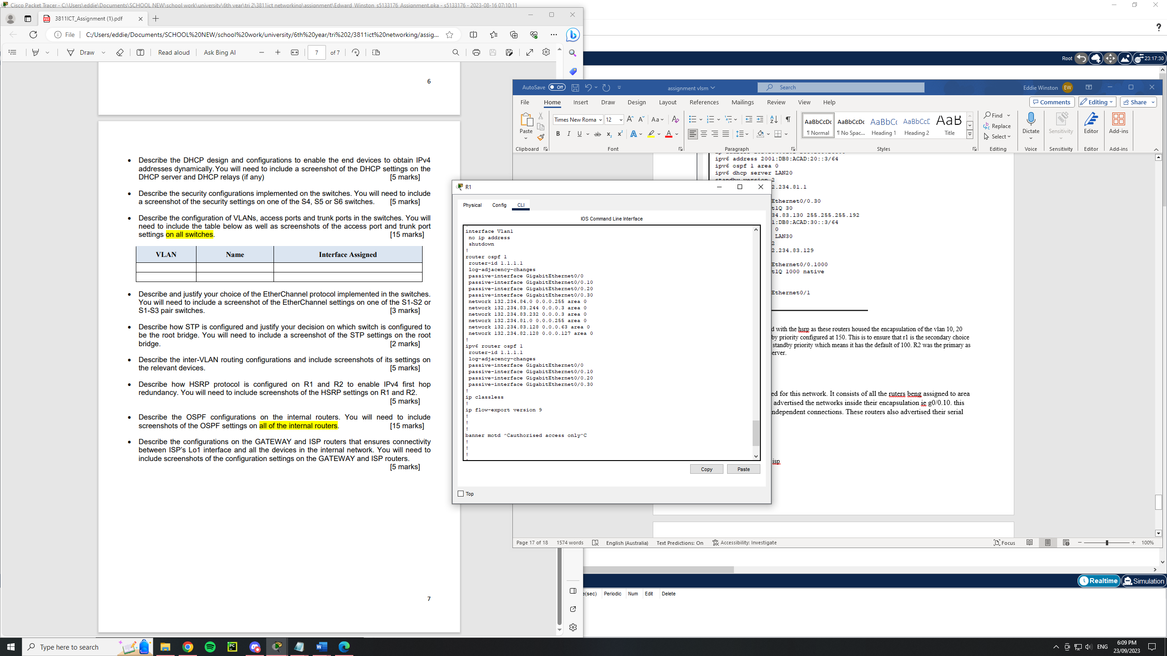

R2

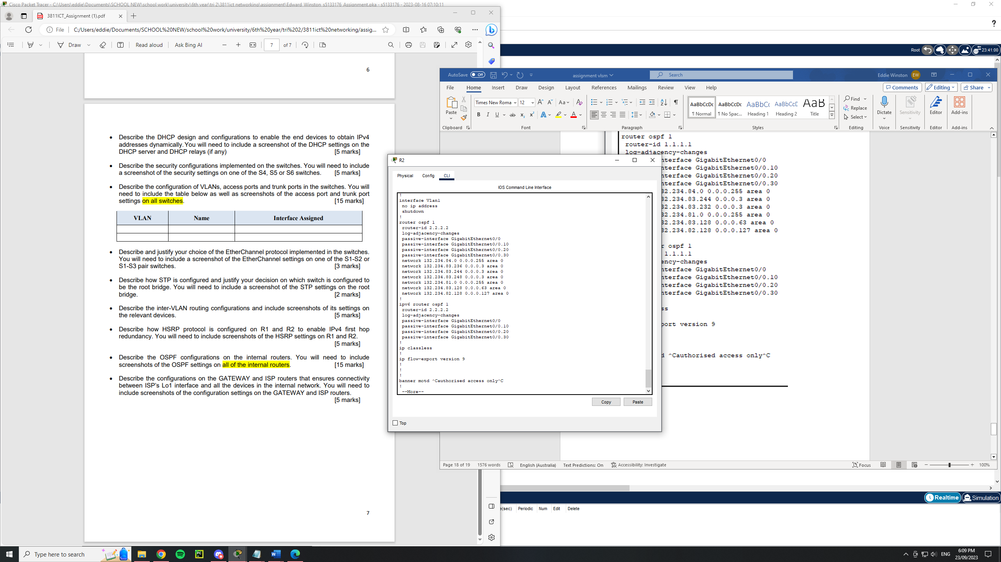

R3

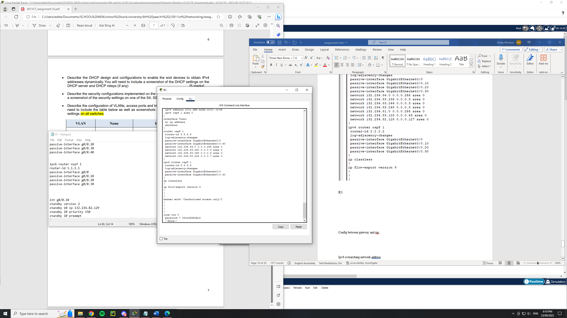

Gateway

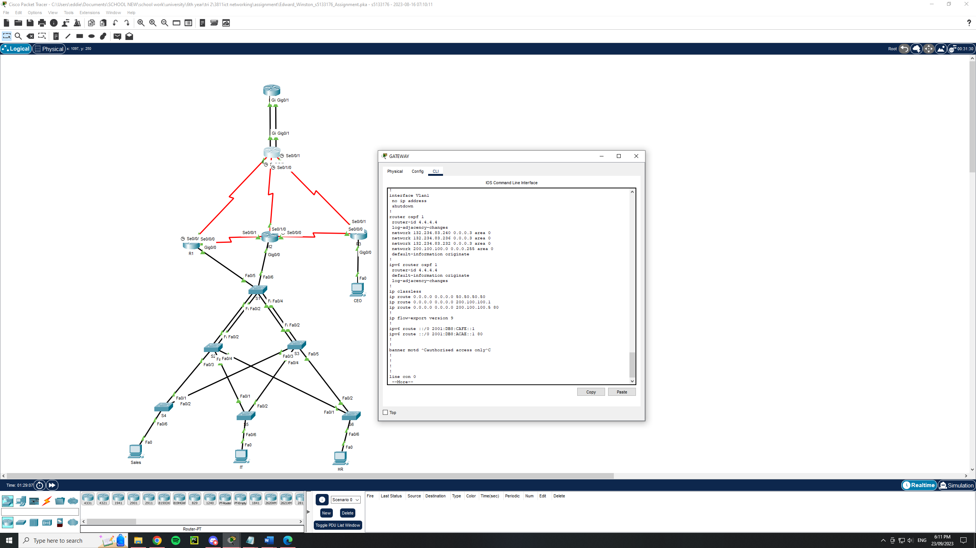

ISP

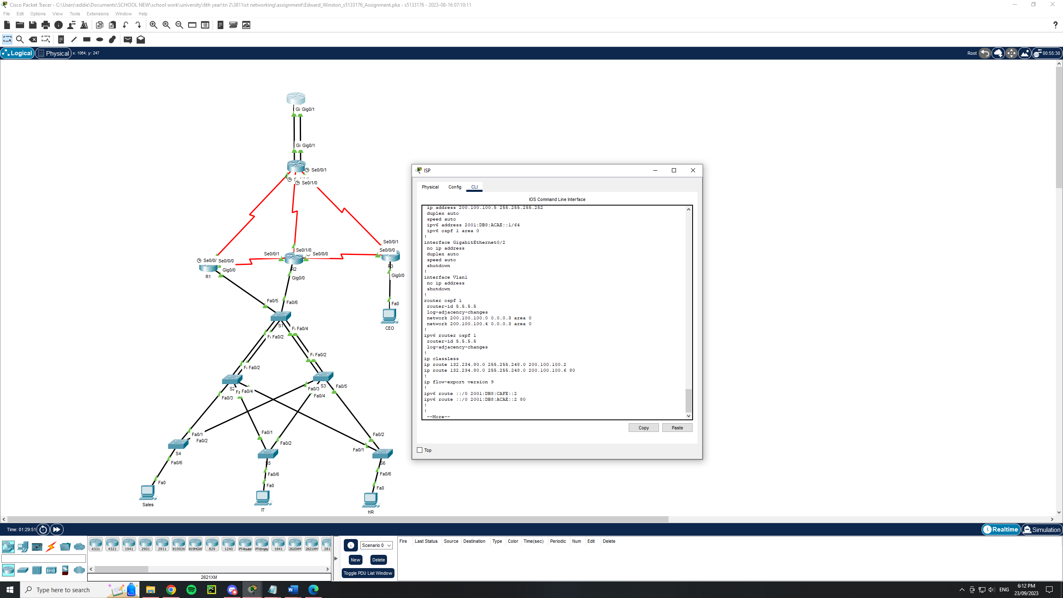

**Config between Gateway and ISP**

The link between gateway and isp has two different connections with the g0/0 being the primary and g0/1 being the backup. In order to achieve this in reality we used administrative distance on the connections by setting the secondary connectuin g0/1 to have an administrative distance of 80. This was done for both ipv4 and ipv6 as well as being done on both routers.

On gateway



On ISP

